Reference number:
Date submitted:
For internal use only

RESEARCH AND KNOWLEDGE EXCHANGE FUNDING

FULL PROJECT PROPOSAL: Stage 2 of 2
For Contracts £50,000 and over

Please indicate the AHDB Sector(s) this application is intended for

Beef & Lamb | Cereals & Oilseeds | Dairy | Pork

This application is made on the basis of the AHDB TERMS AND CONDITIONS with which any organisation receiving funding shall comply with if awarded a contract. Please tick to ensure you have read and accept the terms

Data protection
At AHDB we take the privacy and security of your personal information very seriously. The personal information we collect in this form is for the purpose of processing your research-funding application, including communicating with you and for undertaking a selection process prior to entering any contract. It will never be sold to third parties. The personal information of unsuccessful applicants will be deleted before the start of the next funding round. For further details on how AHDB uses and looks after personal information please read our Privacy Notice at www.ahdb.org.uk/PrivacyNotice.

Further details to help complete this application can be found in the associated Guidance Notes

SECTION 1: PROJECT OVERVIEW

Project title
Full title: …
Short title (levy payer friendly): …

Title of the call under which the proposal is submitted (only where relevant)
…

Short project abstract (Maximum 250 words)
…

1.4 Proposed start and end date
Start date (dd/mm/yy) End date (dd/mm/yy) Duration (months)
… … …

1.5 Applicant organisation
…

1.6 Collaborating organisation(s)
…

1.7 Total cash funding requested from AHDB 1.8 Total project cost including co-funding

(Including VAT) (Including VAT)
£… £ …

1.8 AHDB funding breakdown
AHDB Sector | Cash £ | VAT £ | In-kind £ | Confirmed  Y/N | Decision date  If not yet confirmed
Beef & Lamb
Cereals & Oilseeds
Dairy
Pork

1.9 Co-funding
Organisation | Cash £ | In-kind £ | Confirmed  Y/N | Decision date  If not yet confirmed

SECTION 2: PROJECT OUTCOMES

2.1 Who are the target beneficiaries of the project? Tick all that apply

Farmer/Producer Agronomist Consultant Processor Breeder Vet

Manufacturer Haulier Regulator Food Business Operator Auction Market

Commercial Company Consumer Scientist Other (please state)_______________

2.2 How knowledge exchange integrates into achieving industry relevant outcomes Specify any AHDB in-kind

2.2.1 What approach will be used to ensure project outcomes translate to changes in practice?
…

2.2.2 What engagement with industry will be conducted during the project?
…

2.2.3 How will industry intelligence feed into shaping progress and delivery?
…

2.3 What is the likely timeframe to deliver impact for the industry?
…

2.4 Will further activities/resource be required before the outcomes/impact can be realised?
…

2.5 What environmental benefits are associated with the project outcomes? Tick all that apply

Improve production efficiency Reduce pesticides Reduce GHG emissions Reduce waste

Reduce pollution Reduce resource use Increase biodiversity Improve soil health

No environmental benefits Other (please state)

2.6 Please state any potential negative impacts on the environment
…

2.7 How will success be measured e.g. KPI’s?
…

2.8 Exploitable intellectual property (IP)

2.8.1 What commercially exploitable IP will this project generate?
…

2.8.2 How will IP exploitation be achieved?
…

SECTION 3: TECHNICAL APPROACH AND WORK PLAN

3.1 Concise summary of knowledge relevant to the proposal – cite references where available
…

3.2 Aims and Objectives

3.2.1 Provide a clear statement of the aim of the project
…

3.2.2 State the core project objectives - number each objective separately
…

3.3 Work package details linked to core objectives outlined in 3.2.2
…

3.4 Has a similar proposal been, or about to be, submitted elsewhere, if so, provide details
…

3.5 Are any other research groups in the UK or abroad currently working in the area, if so how will you interact with them?
…

3.6 Will there be collaboration with commercial companies, if so how will this be managed?
…

3.7 Has a statistician been consulted about the proposed project? Provide details
…

3.8 Identify any risks and actions that may prevent or delay achievement of the project outputs
…

3.9 What data management processes and/or accreditation is in place?
…

If animals and or humans are to be used please provide details of ethics review and evidence of compliance with ASPA legislation

No. | Milestones | Organisation  Responsible | Start Date  (dd/mm/yy) | End Date  (dd/mm/yy)
1 | Objective name
1.1 | Milestone short description
1.2 | Etc.
1.3 | Etc.
2 | Objective name
2.1 | Milestone short description
2.2 | Etc.
2.3 | Etc.
3.10 Milestone schedule – linked to core objectives outlined in 3.2.2 Add extra lines as required

SECTION 4: CONTACT DETAILS

4.1 Project applicant
Lead contact name:
Position held:
Email:
Office phone: |  | Mobile:
Organisation name:
Address:
Finance co-ordinator:
Email: |  | Phone:
Signee:
Email: |  | Phone:

4.1.1 What is the organisation’s contribution to the project?
…

4.1.2 Justification of resources
What staff will be employed on the project?
Grade/title | Time spent on project (in days if the project duration is less than a year and in years otherwise) | Funded by AHDB?

4.1.3 Provide details of how any unexpected staff absences will be covered
…

4.1.4 Provide details of any capital equipment requested
…

4.1.5 Provide details of any costs claimed under “other costs”
…

4.1.6 How are the requested overheads calculated and what do they cover?
…

4.2 Collaborator(s) (Complete one sheet per collaborator)
Collaborator name:
Position held:
Email:
Office phone: |  | Mobile:
Organisation name:
Address:
Finance co-ordinator:
Email: |  | Phone:
Signee:
Email: |  | Phone:

4.2.1 What is the organisation’s contribution to the project?
…

4.2.2 Justification of resources
What staff will be employed on the project?
Grade/title | Time spent on project (in days if the project duration is less than a year and in years otherwise) | Funded by AHDB?

4.2.3 Provide details of how any unexpected staff absences will be covered
…

4.2.4 Provide details of any capital equipment requested
…

4.2.5 Provide details of any costs claimed under “other costs”
…

4.2.6 How are the requested overheads calculated and what do they cover?
…

4.3 Co-funder(s) (Complete one sheet per co-funder)
Organisation name:
Key contact:
Position held:
Email:
Address:
Office Phone: |  | Mobile:

4.3.1 Details of contribution (cash and in-kind)
…

…

4.4 Short CVs (Maximum 1 page per CV)
Submit one CV for each partner in the project to demonstrate they have suitable skills to undertake the work.
Name:
Organisation:
Present position:
Key areas of expertise:
Professional profile:
Key publications:

…
SECTION 5: PROJECT COSTS
A separate sheet should be completed for each organisation requesting funding. Please include VAT where indicated, where sub-contracts are used these costs should always be inclusive of VAT.
Please ensure that at least 10% of the total funding amount is held for the final payment (to be paid upon receipt of a final report of acceptable quality).

5.1 Applicant’s requested costs
Costs for: enter organisation name
Organisation’s project reference if applicable:
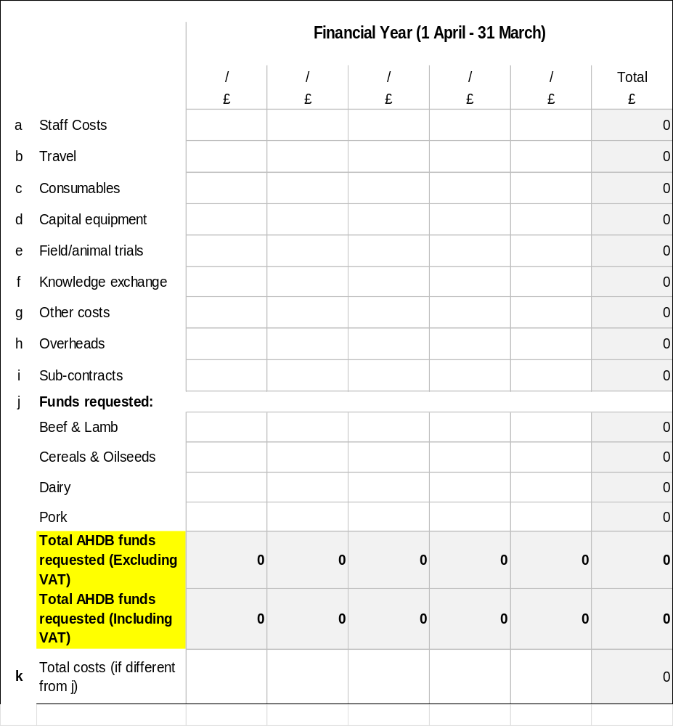

5.2 Collaborator’s requested costs
Costs for: enter organisation name

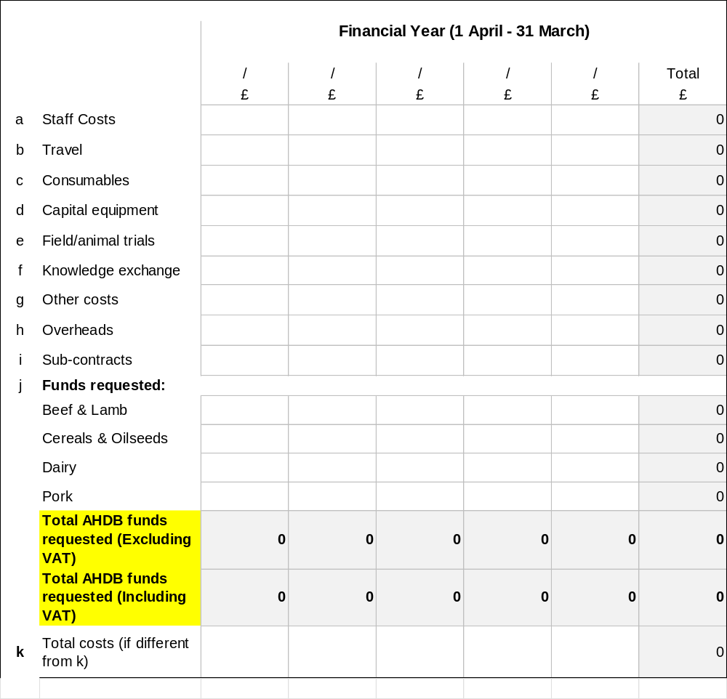

5.3 TOTAL REQUESTED COSTS

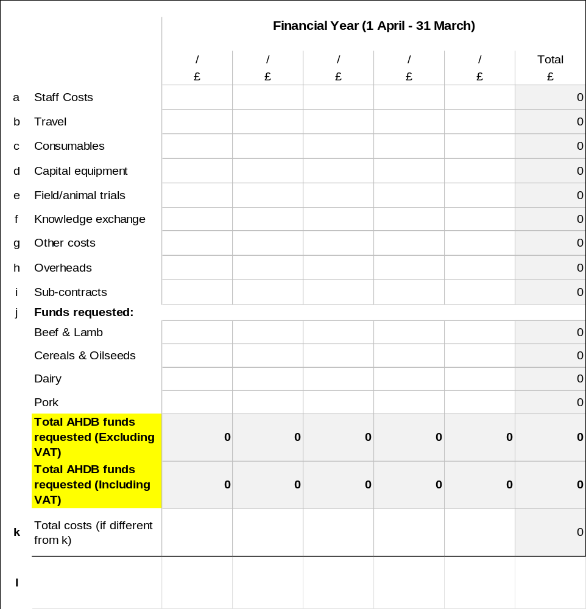

SUBMISSION OF COMPLETED FORMS

Please email a completed copy to: research@ahdb.org.uk

Reference number:
Date submitted:
Assessor:
Sector assessing:
FULL PROJECT PROPOSAL ASSESSMENT

Number | Criteria Title | Description | Scoring | Weighting (%)
1 | Understanding of requirements | • Demonstrates a clear understanding of the project requirements  • Addresses all key points outlined in the RFQ (Request for Quotes)/ Invitation to tender  • Provides a clear, accurate and concise proposal | 9-10: Exceptional quality of response; clearly and concisely provides evidence of capacity to deliver on all aspects.  7-8: High quality response, evidence is clear and concise against all the key points of call.  5-6: Good response, evidence is understandable against the key points of call.  3-4: Fair response with some evidence of intended delivery but with important gaps and/or lacks clarity and/or conciseness.  1-2:Poor response, misses several key points and lacks clarity and conciseness  0: Very low quality, fails to address points outlined in call and/or is incoherent. | 15%
2 | Technical Approach and Workplan | • Feasibility and innovation of the proposed solution.  • Methodology and technical soundness.  • Conveys a clear ambition to deliver practical outcomes for levy payers and has made provision to do so where this is required in the project specification.  • Ensures that levy payers and stakeholders will recognise how AHDB funding and support has contributed to project outcomes included in a clear communications plan.  • Realistically assesses risks and provides practical mitigation strategies.  • Confirms ownership of data to be included in project delivery and that project outcomes will be openly accessible to levy payers.  • Provides deliverables in a format suitable to be communicated to levy payers, where required.  • Provide workplan which includes project delivery and communication methods, for example, frequency of status reports, meetings etc. | 9-10: Exceptional quality, approaches are robust and cutting-edge providing convincing evidence that delivery will result in positive change for levy payers. AHDB’s funding and shaping of the project will be very clear to levy payers and relevant stakeholders.  7-8: High quality, includes well established and robust research/KE practise which can be expected to deliver and result in positive change for levy payers. AHDB’s funding and shaping of the project will be very clear to levy payers and relevant stakeholders.  5-6: Good response, approaches are aligned with the tender but may need some refinement in minor areas. Overall can be expected to deliver positive change for levy payers. AHDB’s funding and shaping of project will be very clear to levy payers and relevant stakeholders.  3-4: Fair response with approaches likely to deliver some of the tender outcomes but with important gaps. Positive changes for levy payers are possible. Recognition for AHDB’s funding contribution may or may not be clear.  1-2: Poor response, approaches are outdated or unrealistic and are unlikely to deliver the RFQ target outcomes. Recognition for AHDB’s funding contribution may or may not be clear.  0: Very low quality, fails to address the key objectives of the tender. | 30%
3 | Experience and Qualifications | • Relevant experience of the team and organization.  • Qualifications and expertise of key personnel.  • Past experience on similar projects.  • Demonstrates or builds in capacity to deliver the work with a focus on clearly visible outcomes and value for money for levy payers.  • Includes interaction with levy payers and relevant stakeholders for project steering. | 9-10: Exceptionally well qualified team with well established credentials for delivering positive and practical changes for the levy payers. Has experienced individuals closely involved with all aspects of delivery and clear supervision and oversight built in for less experienced team members. Plans for levy payer and stakeholder interactions are convincing and will add clear value to project outcomes.  7-8: High quality team with established credentials for delivering positive and practical changes for the levy payers. Inputs by less experienced team members will be closely supervised by experienced team members. Plans for levy payer and stakeholder interactions are convincing and will add clear value to project outcomes.  5-6: Good quality team with past relevant experience of delivering practical changes for levy payers. The team includes a good balance of experience including sound project oversight. Plans for levy payer and stakeholder interaction are acceptable.  3-4: The team has some good relevant experience which may need balancing with additional industry steering to support delivery of practical outcomes for levy payers.  1-2: The team has little prior experience of delivery direct to levy payers and may or may not have some supporting industry steering to compensate for this.  0: Little to no relevant experience or steering from industry to compensate for this. | 20%
4 | Cost and Budget | • Detailed budget breakdown.  • Cost-effectiveness and value for money in the context of the size of the benefit to levy payers and the project delivery plan.  • Inclusion of co-funding | 9-10: Exceptional response with a clear, realistic and detailed financial breakdown which meets budget expectations and gives confidence of cost effective delivery of all required outcomes.  7-8: High level of detail given in the financial breakdown with realistic allocation of cost to project activities and gives confidence of cost effective delivery of key outcomes.  5-6: Good level of detail given to meet majority of the bid requirements, but opens up questions about additional costs that may be necessary for delivery and/or include significant items of expenditure surplus to perceived requirements to deliver the objectives.  3-4: The response falls short and does not clearly evidence how the costs and resources available will deliver the required outcomes.  1-2: The response is very inconsistent and/or contains significant shortcomings.  0: No response or price not clearly linked to milestones, activity, or resource | 15%
5 | Project Management | • Quality of the project management plan.  • Timeline and milestones.  • Resource allocation and management.  • Builds in AHDB and relevant industry project steering.  • Risks and risk mitigation are adequately assessed (eg. Staffing contingency) | 9-10: Exceptional response with clear and pragmatic plans to keep the project on track which anticipates and responds to workplan changes promptly and effectively ensuring swift change implementation by the full delivery team. Ensures added value to project outcomes through project steering from AHDB project manager(s) and industry stakeholders fully to ensure first class delivery.  7-8: High quality response with comprehensive planning in place to keep the project on track. May have some gaps and/or be in excess of need in places.  5-6: Good response with clear planning to keep the project on track. Builds in effective steering from AHDB project managers and industry stakeholders.  3-4: Fair response with key delivery points identified and planned for. Accounts for project steering from AHDB and industry stakeholders.  1-2: Poor response with little evidence that the project will be effectively managed and /or embrace steering from AHDB and industry stakeholders.  0: Very little evidence that either project management has been planned or that the plan outlined will deliver. | 10%
6 | Innovation/Added Value | Includes innovative suggestions that would add value to the project outcomes (10% budget flexibility available for successful cases) | 9-10: Includes exceptionally innovative additional outcomes that clearly add value to delivery of the RFQ objectives with capacity to result in direct short to medium term clearly visible benefits to levy payers.  7-8: Includes innovative additional outcomes that complement delivery of the full RFQ objectives.  5-6: Additional outcomes relate to the main RFQ objectives which may have potential to add value to project delivery with some amendments. May or may not be included in the contract awarded.  3-4: Additional outcomes add little value to the core objectives of the RFQ and are unlikely to add benefit.  1-2: Proposed additional outcomes add no value either to the RFQ objectives or to levy payers.  0: Proposed additional outcomes are unrealistic add no value either to the RFQ objectives or to levy payers. | 10%

