


Purpose, scope and value of farm assurance
26 May 2026

Introduction
The UK Farm Assurance Review calls on NFU and AHDB to lead work to clarify and reset the purpose and scope of farm assurance. This document responds to that recommendation.
Farm assurance schemes are owned and run by different organisations, and each scheme is responsible for setting its own standards and explaining to its members its purpose and scope – and how it delivers value. What follows is a set of principles and concepts providing:
- an explanation of why farm assurance schemes exist
- a practical way of describing assurance types
- a straightforward way of explaining the value assurance can bring to farmers and growers
The aim is to improve understanding, among farmers, levy payers and the wider supply chain, of the scope and purpose of specific schemes

Purpose: why farm assurance exists
At its core, farm assurance exists to enable farmers and growers to show and reassure customers and consumers that the food they produce meets agreed standards.
Through independent audit against those standards, farm assurance supports farmers to demonstrate that food and feed are:
- safe, legally compliant and traceable
- produced in line with recognised good practice
This verification supports due diligence obligations not just for farms but those across the supply chain, which is an important aspect of demonstrating compliance with food safety regulation.
This gives confidence to customers, consumers and regulators, without every buyer needing their own audit system. Where schemes are recognised by regulators, assurance can also support earned recognition and reduce duplication of checks.
Put simply, assurance provides trusted due diligence that food meets the expectations placed on it.

Foundational assurance and enhanced standards
Farm assurance schemes broadly fall into two categories.

Foundational assurance
Foundational standards and/or schemes provide a common baseline that the whole supply chain can rely on. These focus on meeting relevant legal requirements such as food safety, animal welfare and pollution prevention, drawing on relevant widely accepted industry good agricultural practice.
Many retailers, processors and foodservice businesses rely on foundational assurance to source produce with confidence.
Foundational assurance works best when it is:
- clear about its purpose and is well governed
- proportionate in what it asks of farmers
- meets common customer/ consumer needs
- can enable access to multiple markets

Enhanced assurance
Enhanced standards are tiers on top of foundational assurance or dedicated supply chain arrangements that sit above the foundational level. They demonstrate higher or more specific standards, often linked to particular production systems or attributes, such as organic, environmental enhancement, or higher welfare.
Enhanced standards are typically used to:
- access specific markets
- support product differentiation
- justify a price premium
Some assurance schemes combine foundational and voluntary enhanced standards within a single, tiered structure. Others effectively require membership of a separate scheme offering foundational standards as a starting point. Access to enhanced assurance should be driven by choice rather than obligation.
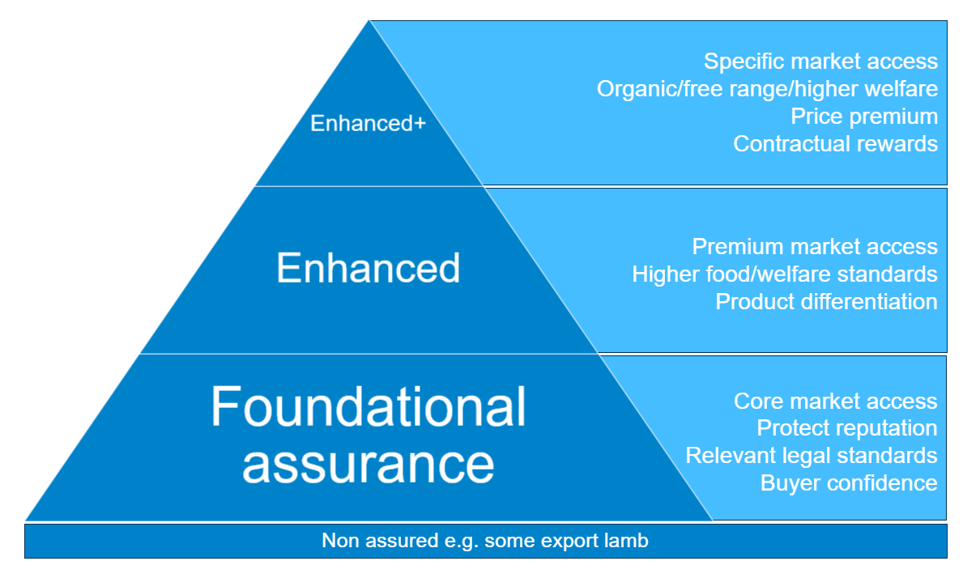

Scope: what assurance should cover
Clear scope is essential for trust. Farmers need confidence about where assurance starts and stops.
Foundational assurance should focus on what is needed to provide confidence in food production across the whole supply chain.
Foundational standards will change over time. This may be driven by new legislation, emerging risks, consumer expectations, supply chain expectations or changes in farming practice. However, assurance is one of several routes that can be used to address emerging policy, reputational or market challenges.
When change is needed, it is essential that scheme owners:
- explain clearly why changes are proposed
- consult meaningfully with scheme members as well as broader supply chain stakeholders
- recognise the cost versus benefit and practical impact on farm businesses such as the impact on domestic competitiveness compared to imports to the same market.
Enhanced requirements should be clearly identified as such, and farmers should be able to see whether they are being asked to meet them for enhanced market access or for a premium.

The value of farm assurance
Farm assurance can and should deliver value in different ways, depending on the type of scheme and the needs it is meeting. In simple terms, foundational assurance provides due diligence and confidence; enhanced assurance supports differentiation and reward.
Across the system, assurance can deliver value by:
- Demonstrating farmers are practicing due diligence within the scope of their scheme, for example:
  - Producers have a responsibility under the Food Safety Act to demonstrate due diligence including the importance of corrective action
  - Customers need high confidence that their supply chains do not present legal or reputational risks. Assurance schemes have a role to play here, within their defined scope

- Supporting consumer confidence in British food, for example:
  - The Red Tractor/YouGov 2025 Trust in Food Index found that 60% of consumers say assurance labels increase their trust in food
  - The British Egg Information Service website states that the British Lion scheme has drastically reduced the presence of salmonella in UK eggs. All eggs that carry the British Lion mark have been produced under the stringent requirements of the British Lion Code of Practice, which ensures the highest standards of food safety
  - An RSPCA Assured/YouGov survey in 2025 found that the majority (62%) of UK shoppers are willing to spend more and buy British higher-welfare-labelled products
  - The Red Tractor/YouGov 2025 ‘Trust in Food index’ found that 92% of adults trust food produced in the UK, with 70% agreeing that UK farmers perform well on animal welfare. Fifty-eight per cent of respondents said that good animal welfare standards are a reason for trusting UK food. The Trust in Food Index - Red Tractor

- Protecting market access for farmers and growers, for example:
  - An AHDB/Blue Marble Trust Survey in 2025 showed that 84% of consumers are happy buying meat/dairy from the UK, well ahead of the next highest country (New Zealand, 58%).

- Reducing duplication of audits and inspections, for example:
  - Dairy hygiene inspections take place every 10 years on assured dairy farms, but every six months to two years on non-assured farms
  - Pig and poultry producers achieving a high standard of compliance with their Natural Resources Wales (NRW) environmental permit can join the Pig and Poultry Assurance Scheme. Each farm saves £1,476 from NRW annual charges and will be visited by NRW only once every three years
  - Schemes are able to collaborate to facilitate joint audits - https://redtractor.org.uk/assurance/joint-assessments

- Providing a platform for enhanced or premium schemes, for example:
  - Red Tractor’s new tiered welfare standards and labelling for UK pig meat aim to reduce complexity for producers and improve consumer choice
  - LEAF Marque certification allows fresh produce, arable, floriculture and livestock farmers to demonstrate a strong commitment to sustainable practices. It is a required scheme for most major UK grocery retailers, and is recognized by global supply chains including Albert Heijn, Walmart and Lidl, as well as financial institutions including HSBC and Barclays Banks, offering preferential financial products to farmers with LEAF Marque certification.

- Helping the industry demonstrate responsibility and good practice, for example:
  - The collaborative development of a robust industry-led approach to reduce ammonia emissions (The Option 4 Ammonia Mitigation scheme) means that a ban on the use of urea fertiliser in England has been avoided. The requirements of the scheme were incorporated into Red Tractor standards in 2024.
For assurance to remain effective, the link between sector requirements and value must be clear. Farmers need to understand whether assurance is providing access, reducing risk or delivering a premium - and on what basis.

In summary
Farm assurance is a shared asset for British agriculture. It underpins confidence, protects markets and supports the reputation of the sector.
It works best when its purpose is clear, its scope is defined and its demands are proportionate. A trusted and proportionate set of foundational standards provides the base on which enhanced standards and market opportunities can sit.
Clarity on purpose and scope strengthens assurance. It demonstrates the value and ensures all have confidence in it.

