https://www.linkedin.com/groups/12757011@wraguk

:: https://ahdb.org.uk/wrag 📧 wraguk@gmail.com

STEERING GROUP MEETING MINUTES

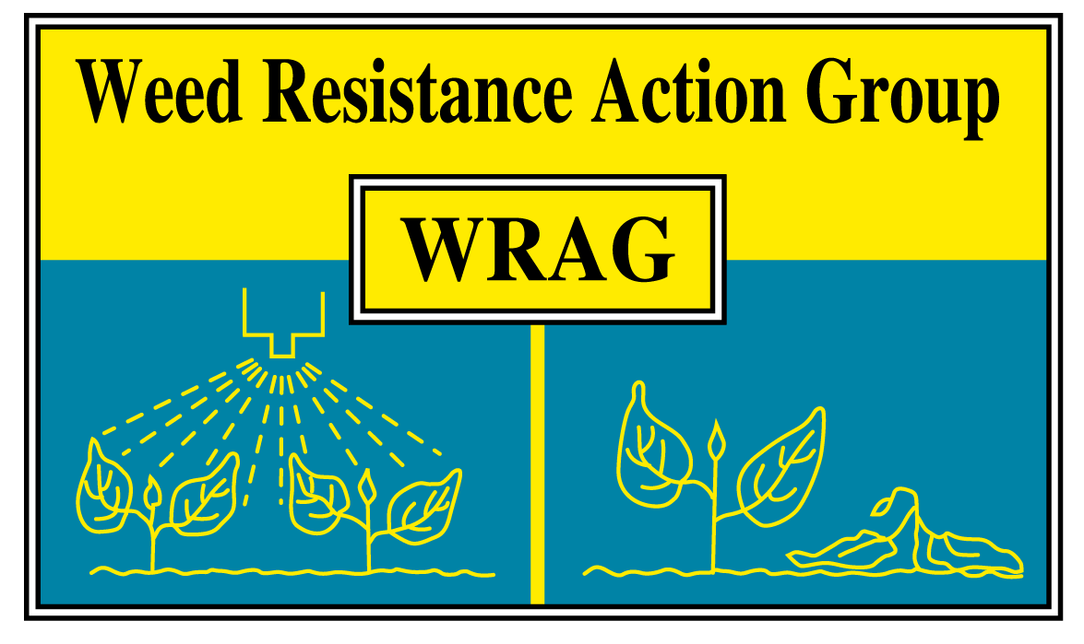

Thursday 12th January 2023

Virtual Teams meeting

Members present: James Clarke (chair, ADAS) Richard Hull (secretary, Rothamsted Research), Stuart Kevis (BASF), Eileen Paterson & Nicola Perry (Corteva), Ingrid Den Hoed & Sean McNeilage (HSE / CRD), Chris Parsons & Roger Bradbury (Bayer), Barrie Hunt (Gowan), Gareth Jones (FMC), David Comont (Rothamsted Research), Peter Hawkins (Syngenta), Kristina Grenz (AHDB), Stephen Moss (Independent), Mark Hemmant (AIC), John Cussans (NIAB)

Apologies for absence: Lynn Tatnell (ADAS)

Membership:

The group welcomes new additions Mark Hemmant who is representing AIC, John Cussans (NIAB), Kristina Grenz (AHDB) and Sean McNeilage (HSE).

The group thanked Eileen Paterson for her many years of service sitting on WRAG and to the industry as a whole and wish her a very happy retirement. Nicola Perry is Eileen’s replacement from Corteva.

Update on minutes of last Steering Group Meeting on 24/3/22:

- Mode of action change – UK grassweeds active document (Richard Hull)

Document up to date and available to view on WRAG pages hosted on AHDB website, older actives removed, and product names updated.

- News update on EHRAC activity (European Herbicide Resistance Action Committee)

At the last EHRAC meeting on the 8/11/2022, a series of presentations were given, below is the agenda:

- Update on EPPO resistance database
- International herbicide resistance database
- Minimizing the risk of glyphosate resistance in the UK (James Clarke, WRAG / ADAS)
- Herbicide resistance in Switzerland since 2011
- HRAC mode of action working group update, focusing on Group 15
- EHRAC update

A discussion was had around the Group 15 actives and how best to communicate resistance messages around such a large diverse group of actives where multiple group 15 actives can be in formulations / tank mixes. (This will be discussed at the next WRAG meeting in November 2023)

At the EHRAC meeting there were 2 presentations of the different (but not competing) resistance databases. The two are databases are, the EPPO database https://resistance.eppo.int/index which catalogues cases for all crop pests and Ian Heap’s https://weedscience.org/Home.aspx which focusses just on weeds. There are differences in the criteria needed to appear on these databases, this information can be found on the respective websites. (Action: Check the UK weed resistance cases on EPPO website, Richard Hull)

There were no new cases for the WRAG group to discuss for addition to the EPPO resistance list. This will be a recurring agenda item for future.

EHRAC is very happy to include talks in which the focus is not just resistance surveys or lists of cases but on resistance management for example.

- Update from CRD (Ingrid Den Hoed)

CRD has undertaken an extensive recruitment drive across the whole organisation over the last 2 years. Many of these new recruits do not have an agronomic background and in all areas it can take 18-24 months to fully train them. Within the efficacy team there have been some changes in staff and their positions within the team. All new starters have basic agronomic training but those who have been in the team slightly longer are being put through a foundation level BASIS training course.

In terms of work priorities CRD is currently focussing on new active evaluations, but also the renewal of existing ai’s and new products. In terms of new herbicide products those containing cinmethylin have been authorised, which is a new active to GB/NI. Many other new products are co-formulations of existing active substances.

Since the last meeting authorisations for products containing carbetamide have been withdrawn and for future meetings CRD will report on any that are new or have been withdrawn.

Mode of Action labelling on product labels is coming into force at the moment and where this is not present CRD will include this. In addition later this year CRD will be updating its guidance on resistance risk assessment and how to label products according to risk. When a draft is complete this will be circulated to the group.

- Italian ryegrass and Wild oats herbicide resistance surveys (John Cussans / NIAB)

NIAB have tested 105 populations, with up to 30% of samples being mixed populations winter and spring oats ( Avena sterilis ssp. Ludoviciana and Avena fatua). Mixed populations appear to be more common than 20 years ago due changes in cropping drilling dates. Identification of the 2 types of oats is key https://croprotect.cl0.ethr.dev/uploads/Wild-Oats-Leaflet-Final-easy-read-11Nov15.pdf, with farmers having more issues controlling winter wild oats.

The data showed low levels of resistance to Laser (cycloxydim), highlighting the possible low levels target site mutations which confer resistance to fop and dim actives. The winter wild oats were harder to control in general than the spring oats. The work also emphasized the strengths / weaknesses of actives within the same herbicide group. Also, that resistance in wild oat is slow to shift, most probably to its in-crossing (grasses like black-grass and ryegrass are out-crossing) and being hexaploid.

For Italian ryegrass, 2 seed surveys have been carried out, the first in 2019 where 50 samples were obtained and in 2021 funded through Bayer a larger, more geographically spread collection was obtained.

For the 2021 samples, approximately 50% of samples were RR or RRR to Axial or Atlantis when tested in pots. Work has also been conducted using residual actives, with about 10% of populations having poor control with flufenacet. This is different to black-grass populations where flufenacet still works well on most populations, but with ryegrass there are populations with little or no control obtained with flufenacet.

For a subset of 22 ryegrass populations, NIAB has looked at the cross resistance to a wide range of actives applied pre and post-emergence. There was a strong correlation for levels of sensitivity to the residual actives (flufenacet, pendimethalin and prosulfocarb), a weaker association to aclonifen.

For the 2019 collection, these populations had a range of sensitivities to glyphosate. This study highlighted that ryegrass has the capability to have high levels of glyphosate resistance.

NIAB are working with IBERS to win funding to look at the population structure / genetics of both Italian ryegrass and wild-oats to understand if these resistance events are occurring in hot spots or develop from within the standing genetic variation.

John also touched on the work they are doing with 2 emerging weed species that are closely linked to the increase in conservation tillage: Burr chervil and Rats tail fescue with 25 and 14 populations respectively. Sulfonylureas are still controlling Burr Chervil very well and for Rats tail fescue, ‘Atlantis’ type actives and glyphosate are achieving good control, but at below field rate control does vary. It was stressed that with both these species attention to detail is vital, especially around dose and timings.

- Bayer stewardship on glyphosate (Roger Bradbury / Bayer)

Roger took the group through the KE activities that Bayer have been conducting in relation to glyphosate stewardship. These include:

- On-going communication of the responsible-use / stewardship messages through field teams interaction with agronomists / advisers delivering advice onto farm (both distributor and independent advisers)
- Sponsoring on-going applied research; recent examples include:
  - Italian ryegrass sensitivity study
  - Application experiment investigating interaction between nozzles and boom height
- Strong engagement with BASIS Classroom on glyphosate stewardship which went live in autumn 2021, with 1092 participants completing the course
- Numerous press briefing / articles published in CPM, Farmers Weekly, Scottish Farmer etc.
- Stewardship highlighted in Bayer’s ‘Crop Focus’ magazine which has ~3800 subscribers
- Advertorials which share best practice and case studies
- Web presence with Grassweed Knowledge hub, technical information and 8 blog posts produced in 2022
- Social media presence
- Topical in-season technical bulletins and stewardship booklet
- Field demo days

AOB

James informed the group there was now a LinkedIn group which members and others interested are encouraged to join. This is likely to be more appropriate for communicating and sharing information to Twitter. https://www.linkedin.com/groups/12757011

Topics for discussion at the next meeting:

- Communicating herbicide ratings on labels (offers please to speak – from users and companies)
- Interpretation of test results and maintaining standards (of population and process): Richard Hull, Stephen Moss
- EPPO database: new cases to consider

Next WRAG meeting on Wednesday 8th November (12:30), will most probably in person at ADAS Boxworth (or hybrid).

