WRAG STEERING GROUP MEETING MINUTES

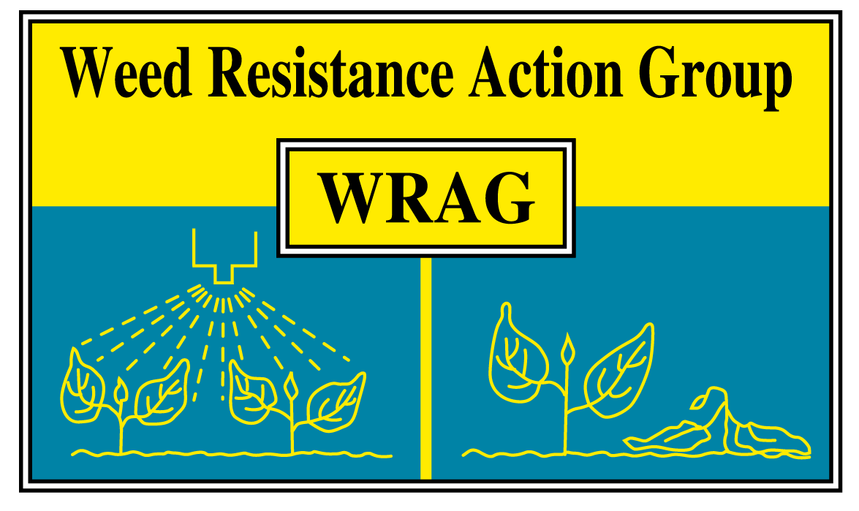

Thursday 1st November 2018

ADAS Boxworth, 1.45pm – 4pm
Members present (9+3):

James Clarke (Chairman), Richard Hull (Secretary), Paul Neve (Rothamsted), Paul Gosling (AHDB), Gordon Anderson-Taylor (Bayer), Eileen Patterson (Dow), Will Foss (AIC), Steve Cranwell (FMC). Jason Tatnell (Syngenta). Plus, Stephen Moss (Independent) Lynn Tatnell (ADAS), Barry Hunt (Bayer).

Apologies for absence:

Ingrid den Hoed (HSE/CRD), Iain Ford (BASF).

The minutes of the last Steering Group meeting (2/11/17) were approved

- Glyphosate labelling / Glyphosate Task Force (GTF)

There was plenty of discussion about labelling of products, especially for glyphosate. For new information that needs communicating if was felt that this would be better done using bulletins and technical guides. These can be produced much quicker than any changes to labels, which are already long enough and in need of simplification.

The UK GTF will produce a document on the sustainable use of glyphosate, looking at maximising efficacy using rates / timings, number of applications and stewardship issues. The timescale for this is by June 2019 and WRAG happy to be co-authors and for the use of its website for access to the document.

- Update from ENDURE glyphosate meeting (Paul Neve)

Paul attended a meeting with scientists from European countries (France, Italy, Denmark, Hungary and Germany) to discuss glyphosate. There were presentations at the meeting about the use of this active and the implications of its loss. There was a general feeling that most other countries apart for the UK where preparing for life without glyphosate in 3½ years’ time and no comment was made about a rapporteur for re-registration.

Germany, France and Denmark have produced technical reports for their governments on the loss of glyphosate. For the UK there is a paper in Outlooks on Pest Management by James Clarke (now available via the WRAG website https://ahdb.org.uk/knowledge-library/wrag). Maybe we need a white paper about the implications of losing glyphosate, centred around environment, economics, agronomy and alternatives.

Following this meeting, ENDURE will lobby for an H2020 EU call for alternatives to glyphosate, including a range of non-chemical control methods (lasers, crimping etc). Also, they hope to produce a paper on glyphosate practices in Europe, looking at various aspects of its use. Finally, it was mentioned that there will be an H2020 call about pesticide free agriculture.

- Communication of MoA labelling

There will be changes to the MoA labelling in future and the time scale is 2023. There was a lot of discussion on this issue and the following points were raised:

- Companies need to know if CRD want to review / authorise any such changes, or whether they can go ahead without them.
- Communication of any changes is a challenge and WRAG will help in anyway in can all the way through the process.
- Following on from the above, the supporting data / evidence and KE will be more important than the changes to the label itself.
- All companies are aware of this issue and have had discussions internally, either before or after the WRAG meeting

- Herbicide resistance testing

There was common agreement that the current testing guidelines will be updated as there are a few new tests available since the document was produced. The revised version of the guidelines will not be printed, but a PDF version placed on the WRAG website. Discussion needed on how to circulate to a wider audience. The new version should be ready for comments early 2019.

- Discussion on implications of move towards no-till farming and effect of pre-em residual efficacy and resistance evolution

A limited number pre-emergence herbicide labels have very specific information on product efficacy and % of organic matter, with most having no information. Read, Metcalfe et al. Pest Management Science paper (2017), showed reduced control at relatively low OM levels. Points raised included differing results obtained of % of OM from different test facilities.

Action: Ingrid, is there a standard procedure for active ingredient testing and organic matter levels?

- Post-meeting note: in late December Steve Cranwell informed WRAG that he would be retiring from FMC. His position on the Steering Group will be taken up by Gareth Jones (FMC). Membership is kept under continual review, however given the importance of glyphosate in the current discussion maintaining this link was considered to be very important. James Clarke emailed Steve and Steering group members to inform them of this. On behalf of WRAG James emailed Steve saying “Your involvement and interaction both within WRAG and outside has been very important in what we have achieved and produced – thank you. It is the combined efforts of all participants that make us able to produce and communicate meaningful and practical guidelines and messages. I am pleased to be able to thank you on behalf of current and previous members of WRAG and all of us wish you a happy retirement.”

Date and location of next meeting

31st October 2019 at ADAS Boxworth, start time approx. 1.30 -1.45pm

