Twitter: @wraguk email: wraguk@gmail.com

WRAG STEERING GROUP MEETING MINUTES

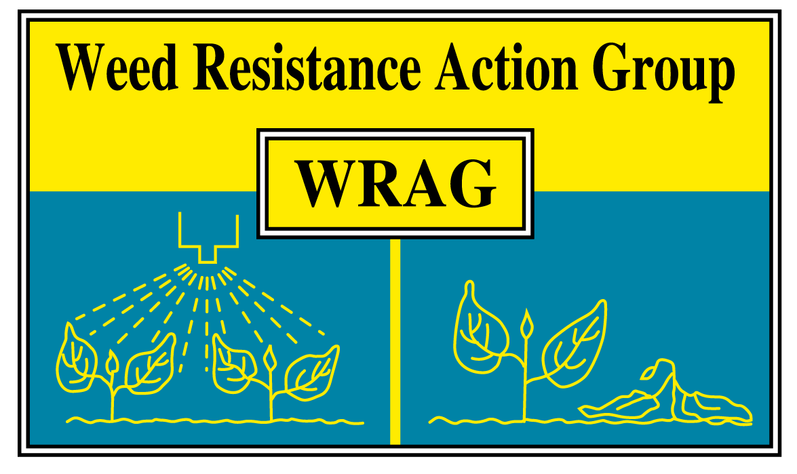

Thursday 24th March 2022

Virtual Teams meeting

Members present: James Clarke (chairman, ADAS) Richard Hull (secretary, Rothamsted Research), Stuart Kevis (BASF), Eileen Paterson (Corteva), Ingrid Den Hoed (HSE), Chris Parsons (Bayer), Barrie Hunt (Gowan), Gareth Jones (FMC), David Comont (Rothamsted Research), Georgina Wood (Syngenta), Lynn Tatnell (ADAS), Catherine Harris (AHDB)

Apologies for absence: Stephen Moss (Independent)

Membership:

We welcome John Cussans (NIAB) and Mark Hemmant (Agrovista, representing AIC) who will join the group starting with the October 2022 meeting.

Update on minutes of last Steering Group Meeting on 28/10/21:

EPPO resistance database and cleansing/reporting cases – any need for action?

- This will become a recurring agenda item for all future WRAG meeting for the group to discuss
- The aim of this database is to share, across the EPPO region, information about documented cases of resistance to plant protection products (PPP) for weeds, pests and pathogens.
- Please send any comments on existing cases listed on the EPPO database to Ingrid Den Hoed who will pass it onto the relevant individual

Mode of action resistance labelling – update

- In order to support the widespread adoption of responsible resistance management practices, members of the industry body ‘CropLife International’ have made a voluntarily commitment to include Mode of Action (MoA) icons and groups on all product labels by 2023. Some companies are already including this information on draft labels when making submissions to CRD. However, where this is not done CRD are requesting that such information is included.

- Mode of action change – UK grassweeds active document (Richard Hull)

A revised version of a document that lists all herbicide active that have some level of control of black-grass, Italian ryegrass and wild-oats has been updated. This document now includes recent changes to the herbicide mode of action groups and includes the existing lettering system with the new numbers scheme. This new document will hopefully go onto the WRAG web pages by mid-April. Only herbicide actives currently approved are listed.

There was a discussion around adding other grassweeds to this document, such as bromes or rats tail fescue. The group felt it best to just keep this table to the three existing species and if needed WRAG will produce separate tables for other grassweeds in future.

This table is intended to be a living document, therefore please email Richard Hull if any alterations need to be made, either adding new actives or removal from the list.

- Resistance risks of applying sub-optimal dose rates of glyphosate – need for any communications? (James Clarke)

Bayer has been very proactive in this area already in the farming arena, but are keen to do more and a discussion was had around what else could done and where could the information be found. In February Bayer had an article in the Farmers Weekly highlighting the key issues on the subject and have been working with the AICC on podcasts and blog posts. They have a booklet coming out in April’s CPM magazine plus more coverage in upcoming September issue which is the key timings for guidance on control prior to autumn sown crops. It was suggested they could contact Pro Operator magazine to target the spray operator sector and NACS which is a contractor’s magazine.

WRAG is happy to help with the dissemination of information in anyway it can. AHDB have said they can put out something on their IPM hub which will link to the ‘Guidelines for minimising the risk of glyphosate resistance in the UK’ which are on the WRAG website.

Roger Bradbury (Bayer) who is leading this campaign will attend the next WRAG meeting to give an update.

- CRD update (Ingrid Den Hoed)

Training up the new starters has been a priority for staff that have joined in the last 6 – 12 months with another round of recruitment soon. There has been a big focus on evaluation work recently and there will be a call for new research / project ideas, but not primarily focused on weeds to date. If there are any suggestions for small R&D projects related to weeds then these should be sent to Ingrid initially.

- Review of two black-grass genome projects / papers (David Comont)

Overview:

Both studies used a herbicide sensitive population for sequencing the genome – For the Bayer genome that was the Rothamsted Broadbalk population, which has never been sprayed with herbicide. For the BASF / Max Planck genome they used a sensitive German population. Both studies have then also done some additional sequencing of herbicide resistant populations, to get some insight into the genetic basis of resistance. Broadly, the Bayer genome looked at non-target-site resistance, while the BASF genome looked at target site.

- Blackgrass is a diploid species, and the two studies confirm that the genome is arranged as seven chromosomes.
- Both studies confirmed that the genome is large, at about 3.5 Giga base pairs long. That’s not as big as Barley or Wheat, but it is still large. Lolium perene is 2.5 Gbp, rice 0.5Gbp.
- Both studies also found that the genome was also very heterozygous.
- Blackgrass has a large, relatively diverse and plastic genome.

BAYER genome:

- For the Bayer, Clemson, Rothamsted genome the focus was enhanced metabolism-based herbicide resistance, specifically to the ACCase herbicides, as screened using fenoxaprop.
- The paper took two field evolved populations with NTSR, and these were Peldon and one from the Rothamsted collection called Lola91 and generated seed lines with a standardised genetic background, after a couple of generations of crossing they identified the most- and least- resistant plants by screening with fenoxaprop, to use for sequencing of gene expression and DNA mutations which gave robust material to look for genetic architecture associated with NTSR resistance.
- The study found was that out of 20,000 genes studied, 68 were consistently associated with resistance in both populations, mostly with increased expression levels.
- What the results also showed though is that 341 and 234 genes were uniquely associated with resistance (differentially expressed) in one population or the other – but not both.
- As expected there were several GSTs, P450s, ABC transporters up-regulated in the ‘R’ plants, which have all been implicated in the past.
- We expect there to be some genes like this just due to chance – but it is probable that some of these genes represent part of the resistance architecture which is specific to the population.

Overall, this study has shown that:

- a certain ‘core set’ of shared genetic architecture for enhanced metabolism of fenoxaprop, and confirms the importance of AmGSTF1 and two other reported candidate genes.
- each population also accumulates its own unique set of mutations and broader changes in gene expression, which probably stems from differences in the standing genetic variation between populations.
- ‘it’s complicated’ – but it has given us a good set of further targets to explore for how causative they are in the resistance phenotype.

BASF / Max Planck

- As mentioned above, they used a German herbicide sensitive population as their reference material for constructing the genome.
- Used a collection of 47 European blackgrass populations and screened a total of a 1000 plants to look at the origin and diversity of Target-site resistance to the ACCase and ALS chemistries.

- Firstly, they looked at genome wide mutations, and used that as the basis for a population-genetics study
- They don’t present a huge amount from that, other than to say that there were a few broad groupings which were genetically more similar. So, Belgium (BE), the United Kingdom (UK), Luxemburg (LX) and France (FR) were genetically similar. The German populations had three different sub-groups with slightly different genetic basis. And the Netherlands was most different from all others. We don’t really know the exact reasons, but it’s probably related to the way Blackgrass semi-recently spread across Europe.

- They took a quick look at non-target-site resistance, screening 61 resistant and 61 sensitive individuals – again this is ACCase resistance, screened using pinoxaden.
- As in the previous study, they found several significant SNP mutation markers associated with resistance and those genes associated with these regions contained things like glucosyltransferases and so on. But really that’s where this paper stops and moves onto target-site resistance

- For TSR - rather than sequencing just TSR mutations, they sequenced the entire ALS and ACCase genes and most importantly, they also sequenced the bits of DNA flanking those genes on either side, creating a set of sequences known as haplotypes.
- The Target-site mutations they found all the usual suspects, which varied a little from country to country, but matches pretty well with what we already know.

- For both genes they found three broad clusters of haplotypes.
- For the ACCase in particular, those three groups actually included representatives from all countries tested, which suggests those different haplotype clusters arose before the widespread geographic spread of blackgrass across Europe.
- Within any single population, they also found a whole range of different haplotypes, and importantly they found that the same target-site mutations was often present in multiple different genetic haplotypes within the same field
- This suggests is that the mutation didn’t just arise once and then spread – instead it’s more likely that the same mutations have arisen lots of times in different genetic lines of blackgrass. – so multiple independent evolutionary origins.
- That leads to the next question then of how long ago did these TSR haplotypes arise – i.e. are they the result of de-novo mutations after herbicide selection, or did they arise a long time ago and have been maintained in the standing genetic variation?
- To answer that question they ran a whole load of complicated computer simulations, artificially simulating TSR mutations over very long timeframes.
- Overall, the models with widespread TSR as part of the standing genetic variation matched the true results much more closely than models of recent de-novo mutation.

Overall, this study has shown that:

- TSR mutations were actually much more widespread before the introduction of herbicides that perhaps we would have naively thought.
- Firstly it suggests that fitness costs of the TSR mutations are very low, if they’re there at all – because otherwise those mutations would have been purged much more readily.
- Secondly it highlights (as with the NTSR study), that standing genetic variation for target-site resistance was probably already present in most populations.
- Herbicide selection has acted on a field-by-field basis on the standing genetic variation and resulted in parallel evolution of resistance – with different pathways or haplotypes selected depending on the pre-existing mutations or genetic architecture present within the population.

AOB

NIAB have been working with Bayer screening a large collection of UK Italian ryegrass populations to glyphosate and will report the findings at the next WRAG meeting.

Next WRAG meeting on Thursday 27th October 2022, location / place to follow if not over Teams.

