WRAG STEERING GROUP MEETING MINUTES

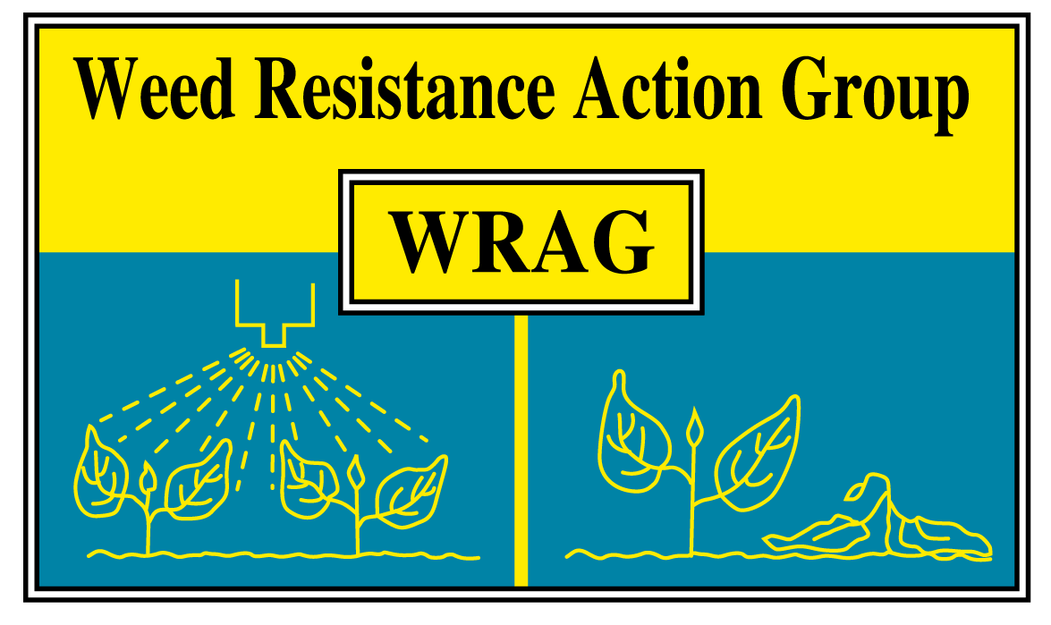

Thursday 25th March 2021

Virtual Teams meeting

Members present: James Clarke (chairman, ADAS) Richard Hull (secretary, Rothamsted Research), Stuart Kevis (BASF), Eileen Paterson (Corteva), Ingrid Den Hoes (HSE), Don Pendergast (AHDB), Stephen Moss (Independent), Chris Parsons (Bayer), Georgina Wood (Syngenta), Barrie Hunt (Gowan), Gareth Jones (FMC), Clare Bend (AIC)

Apologies for absence: None

The group would like to thank Paul Neve and Joe Martin for their hard work while sitting on WRAG.

Minutes of last Steering Group Meeting on 31/10/20:

- ADAS/AHDB-funded glyphosate project report has been finished. Once the final report is loaded to the AHDB website, we will circulate the link and add to the WRAG website.

- Tom Balls has now retired and the matter has been dealt with.

- When updating the WRAG documents with new MOA information, will use both letters and numbers. This will be carried out by the next WRAG meeting.

- Updating resistance status – do we need to? how? Who?

A planned update on the ‘Herbicide resistance status of UK weed species’ is planned for this year. The last one was in 2014. Normally this would be published in a AAB CPSB conference paper, but there are no plans to hold this event in the foreseeable future.

Richard Hull will lead with input from ADAS and all the companies. The current plan is to publish in Outlooks in Pest Management. It was felt that this time this paper should focus on new emerging threats / species. However, it was acknowledged that black-grass would still have a large focus as this is still the most studied herbicide specie.

- New resistant species? (e.g. fumitory) do we have or need tests? How do we fund these?

The question was raised about do we need to more about emerging weed problems / issues, with fumitory raised as one such species. There was discussion around the funding of this type of work; one outcome was agreed that the work should be independent. On the theme of funding, AHDB are working on a long-term strategy for their monitoring pest and resistance programme. Also on testing, we believed that NIAB have recently launched a herbicide resistance testing scheme.

Action: Don said he would update the group on AHDB pest strategy at the next meeting.

Action: With NIAB moving into the field of resistance testing, the group would like to have a representative at these meetings, so John Cussans will be asked to join WRAG.

- Resistance wording on labels

There was a discussion around the resistance risk guidelines and labelling. The current guidance is available at https://www.hse.gov.uk/pesticides/pesticides-registration/efficacy-guides/index.htm and is in the process of being reviewed. There is guidance on both general principles and specific wording on herbicides. Ingrid had circulated some aspects for consideration and, based on the discussion, it was considered these could be simplified significantly. Linking the labelling to the resistance matrix (herbicide and weeds) was considered worthy of consideration and a way to simplify to requirements which vary according to status in UK. For instance, ‘weeds in UK known to be resistant’ means must read guidelines; there is a ‘risk of resistance in weeds this controls’ means the guidance helps; and in all cases need to integrate cultural control. Ingrid will review and bring a new document to the next meeting, as well as updating the ‘general principles’ to create a clear link between risk assessment and label wording .

- Approvals post Brexit

This process is on-going and there could be numerous scenarios, approvals could be; GB only, GB + NI, NI only.

HSE / CRD have set up a task force to investigate this. There is also currently work ongoing to try to complete evaluations, especially EAMU authorisations (led by Mark Curtis).

- Low input/Regenerative agriculture – is resistance management properly factored in?

A discussion was had around the idea that certain ais are bad or having a negative effect on soil health. An issue raised was the mixing on glyphosate with fulvic acid to reduce the dose of glyphosate applied. WRAG would draw attention to the glyphosate guidelines published on the website about the fundamentals of good control.

Action: Clare Bend offered to include some glyphosate + fulvic acid treatments into slot trials in the future. Clare to liaise with James and Richard (and any others who would be interested) to work out the treatments.

- New HRAC coding – issues, opportunities, issues?

It was noted that there are differences in the potency of actives with a mode of action group. WRAG would like a greater ability identify actives within these sub groups. For example, could ACCase be 1a, 1b and 1c for fops, dims and dens? Also this could be used to differentiate the ALS sub groups.

- AOB

None

Next WRAG meeting on Thursday 28th October 2021, time and place to follow.

