WRAG STEERING GROUP MEETING MINUTES

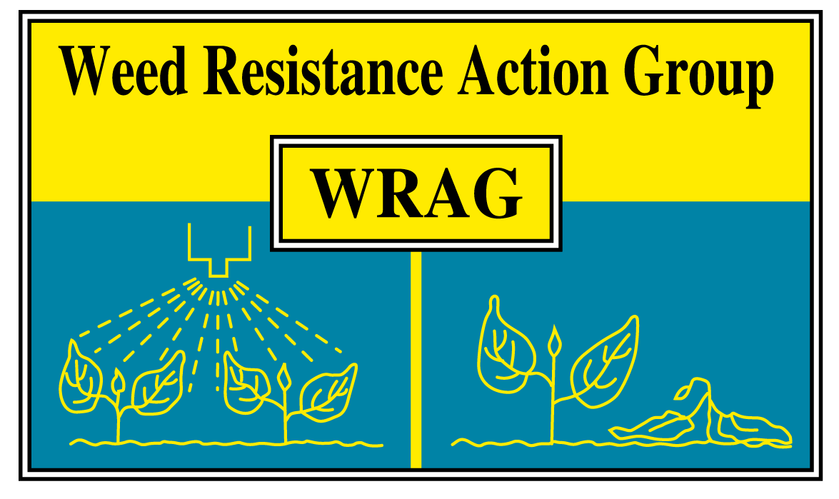

Thursday 29/10/2020 10.00 - 12.00

Online Teams meeting

Members present: James Clarke (chairman, ADAS) Richard Hull (secretary, Rothamsted Research), Stuart Kevis (BASF), Eileen Paterson (Corteva), Ingrid Den Hoes (HSE), Stephen Moss (Independent), Paul Neve (AHDB), Lynn Tatnell (ADAS), Chris Parsons (Bayer), Georgina Wood (Syngenta), Barrie Hunt (Gowan), Gareth Jones (FMC), Clare Bend (AIC)

Apologies for absence: None

Minutes of last Steering Group Meeting October 2019: All actions carried out

Updating glyphosate resistance guidelines, in light of project findings and attached email from Tom Bals:

AHDB funded glyphosate project finished and report the is being finalised. The key outcomes from the project are listed below, which are all about maximising efficacy. This project looked specifically at black-grass and Italian rye-grass, not other species. These key findings will be used to tweak the WRAG glyphosate guidelines, no major revision needed (Action Lynn Tatnell).

Key points to update in the WRAG Guidelines:

- Application timing: Black-grass and Italian ryegrass is GS12-13 is optimum
- Rate: Glyphosate >540g is critical for optimal control
- Weed size: Tillering plants (>GS21-22) require a higher glyphosate rate (720g +)
- Temperature: Extremely important at application, enhancing or reducing control
- Cultivation: Stale seedbed (depth 5cm) essential to increase black-grass control
- Stale seedbed: Maximum of two glyphosate application applications, with a well-timed cultivation (suitable for season, soil type, previous cropping etc.)

There was a discussion around the efficacy of glyphosate and temperature at time of application. Experimental work on this project did not look into this specifically but noticed poorer control in colder temperatures. As second question was around the application when soils are dry. The group said that efficacy could be lower than normal due to dry soils, the same as when the plant is under other stresses.

There was a comment there were no label changes on glyphosate labels yet from the companies.

Bayer has trials looking at maximising glyphosate efficacy in 2020 – 2021. WRAG will be happy to help with any dissemination of results coming from these experiments.

There was a discussion around an email sent by Tom Bal. His concerns about the WRAG glyphosate guidelines were linked to the use of CDA equipment, and predominately for amenity use and use at low volumes. (Action, James Clarke will ring Tom).

There was conversation about harmonizing terminology around band spray application. The following is what we should all be using when discussing this topic:

Band spraying = to the crop row only
Inter-row = non crop row

Update from CRD / HSE

Ingrid stated that the MOA labelling is waiting for the final sign off in November 2020. (Action, update WRAG documents with new MOA, Richard Hull)

There is lots of work going to be ready for Brexit, with issues around protocols for Northern Ireland. The was discussion around approvals post Brexit. Firstly, will resistance issues play a role in decision making in the UK. It was felt that resistance will still be below human and environmental impacts when assessments are carried out. HSE may make decisions on renewals or for new actives quicker than the EU, so there could be some divergence. The issue around NI was discussed. NI will continue to follow EU legislation. So, you could have approvals for just GB, just NI or both. Also, approvals in NI may need extra documentation if the risk assessments differ between the UK and EU. To complicate things further you could get all 4 devolved nations making different decisions on actives in future.

EHRAC interaction

The European HRAC is finding out what other resistance action groups in Europe are active and what they are doing (Action, James Clarke forwarded information onto Eileen Paterson). It appears that the UK WRAG is one of the most active and we are happy to help in the future in any way we can with EHRAC, for example with new MOA labelling. It was proposed that a representative of EHRAC could join our next meeting in March 2021.

Membership

The WRAG committee would like to thank Paul Neve (AHDB, formally Rothamsted) for his time spent on the group. Provisionally his AHDB replacement and on this group will be Don Pendergast.

There a comment about the need for NIAB member. (Action, this will be discussed before the next meeting).

AOB

Attached to this email is the latest paper (summary only) from Stephen Powles on cyp450 NTSR resistance in rigid rye-grass. I have also attached the Nature Communications paper Paul Neve commented on.

There a question about whether the presence of ALS resistant brome has been raised widely enough. The AHDB project finishing early 2021 when the work will be widely publicised. Links below to farming press and ADAS articles on this subject.

https://www.farminguk.com/news/als-inhibiting-herbicide-resistance-in-bromes-identified-in-uk_55092.html

https://www.adas.uk/News/als-resistance-in-bromes-identified-in-the-uk

https://www.fwi.co.uk/arable/crop-management/weed-management/scientists-discover-herbicide-resistant-bromes-in-uk

The BCPC Annual Weed Review is virtually on the 3rd December 2020, invitations are log in details to be sent out shortly. They need one more PhD or early career scientist to present.

Date and location of next meeting

Last week of March 2021, mix of in person / Teams??

