WRAG STEERING GROUP MEETING AGENDA

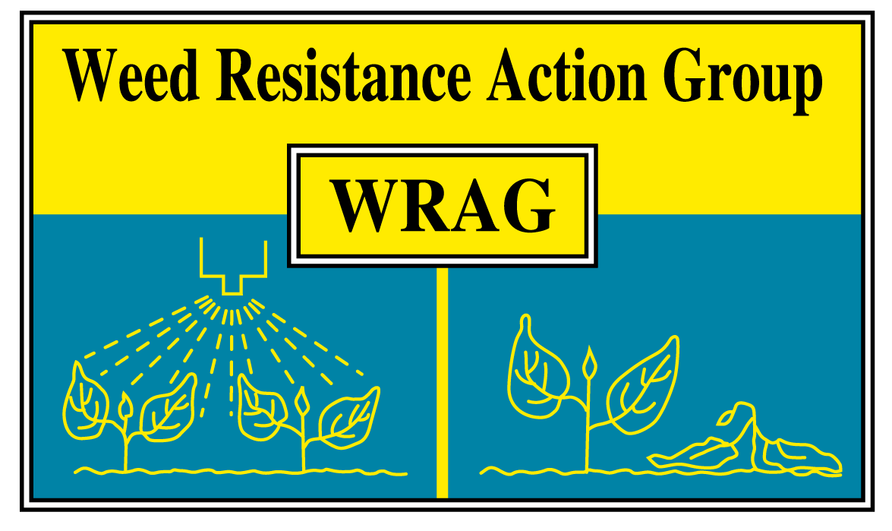

Thursday 31st October 2019

ADAS Boxworth, 1.45pm – 4pm

Members present: James Clarke (chairman, ADAS) Richard Hull (secretary, Rothamsted Research), Stuart Kevis (BASF), Eileen Paterson (Corteva), Ingrid Den Hoes (HSE), Joe Martin (AHDB), Stephen Moss (Independent), Paul Neve (Rothamsted Research), Lynn Tatnell (ADAS), Jamie Mackay (AICC agronomist), Chris Parsons (Bayer), Jason Tatnell (Syngenta)

Apologies for absence: Barrie Hunt (Gowan), Gareth Jones (FMC), Clare Bend (AIC)

Minutes of last Steering Group Meeting on 1st November 2018: There were no matters arising that are not covered on the current agenda.

Herbicide resistance testing discussion (RISQ, BRED, flufenacet tests)

The new WRAG testing document was discussed in some detail at the meeting and about how to communicate to a wider audience when finished (finished summer 2020). Forwarded to larger WRAG mailing list and link below.

https://projectblue.blob.core.windows.net/media/Default/Imported%20Publication%20Docs/AHDB%20Cereals%20&%20Oilseeds/Weeds/WRAG/WRAG%20Maximising%20the%20benefits%20of%20herbicide%20resistance%20testing%20(June%202020).pdf

There was a lot of discussion around what tests are used and by whom. The Petri-dish tests were discussed by Jamie Mackay and how he uses the data obtained. He said they can be useful to look at trends of resistance and as another piece in the puzzle during discussions with clients. These tests work well but need careful interpretation and good standards. May miss low level of resistance as only a single dose used and may miss new cases. The dose used matters.

Jamie Mackay raised the issue of not having a reliable dish test for flufenacet. Richard Hull commented that this had been trialled in the past, but with not much success. This is due to a lack of a high flufenacet resistance standard and there not being enough difference between the susceptible and other populations.

A discussion was had around the new Mologic Bred resistance test kit. It was felt that differences between susceptible and resistant populations of black-grass can be picked up, but for most populations the reader is needed. The test is good for farmer engagement due to the speed and shows that resistance is likely, but in most cases more testing in pots / dishes would be needed. The results are not easy to interpret without the reader and that the methodology is prone to errors due to numerous factors (temperature, leaf amount, shaking period).

Some other issues were raised around testing; a lack of knowledge on cross-resistance from using a single active for NTSR.

Testing was highlighted at the AHDB Agronomists Conference by Richard Hull and David Comont of Rothamsted Research.

The group would like to thank Jamie Mackay for his input.

Glyphosate labelling / glyphosate task force (GTF)

Glyphosate is reaching the end of the renewal process and is near the end of the process (6 -9 months). Timetable for new labelling being discussed.

The WRAG guidelines are still robust for glyphosate weed control, with more research pending which backs these up.

Communication of MoA labelling

Need to update WRAG documents in the light of the changes to HRAC system for MOA labelling which comes into force early in 2020.

There was a discussion about how WRAG can help with the communication of this when the change happens. All felt that a combined / consistent messages are needed.

ALS sugar beet and latest status and feedback from field

Small demonstrations have been carried out so far. Comprehensive guidelines produced for good practice to be rolled out. WRAG is happy to help out dissemination of the information.

Other topics

Cross compliance on brand swapping

This discussion centred around the using different products in the same season with the same actives. This is not just for pre-emergence actives (flufenacet) but also with actives like propyzamide.

Ingrid responded to the question below:

The question was whether: By changing products containing the same active substance can I apply more than the maximum dose specified for any one product?

The response is below:

Such practice is strongly discouraged. It could be seen as going against the legal requirement to take all reasonable precautions when using pesticides to protect people, animals and the environment. It is also possible that the repeated use of similar products could lead to the permitted maximum residues levels in the treated crop being exceeded.

The wording of this was subject to a great deal of debate at the time but realise that this was published some time ago now.

ENDURE glyphosate paper update

Paul Neve updated the group about this exercise. This paper will bring together data from across most European countries on the use of glyphosate; how much is applied, where and the % of all actives applied. Below is a link to the final document.

http://www.endure-network.eu/de/about_endure/all_the_news/report_glyphosate_use_in_europe

AOB

WRAG would like to thank Gordon Anderson Taylor and Iain Ford for all their work whilst being members of the group and wish them all the best.

Date and location of next meeting

29/10/20, Virtual Teams meeting

