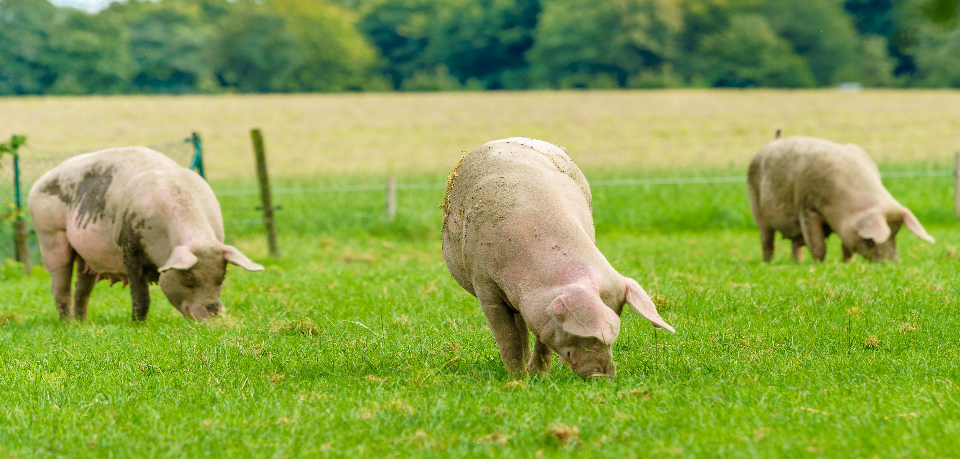
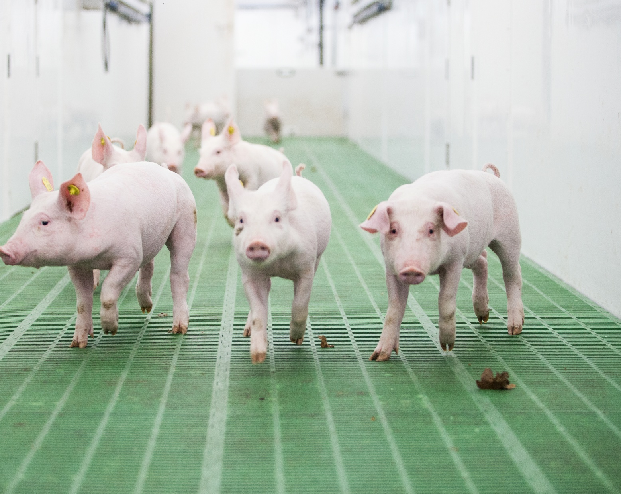



Building on progress, shaping the future.
2026

Contents

Contents 2
Supporting organisations 4
Executive summary 5
Foreword 6
Introduction 7
UK agriculture greenhouse gas emissions 7
Net zero and the role of agriculture 8
Lowering livestock emissions 8
Overview of the British pork sector 9
Climate change and sector resilience 10
Looking ahead 10
Pork Environmental Roadmap 11
Purpose 11
Strategic priorities 12
Underpinning success 12
Governance 12
What is the sector already doing? 13
Life cycle assessment of British pork production 13
Net carbon 17
Air quality 27
Water stewardship 30
Slurry, manure and nutrient management 31
Biodiversity and natural resource stewardship 34
Waste and recycling 36
On-farm energy 37
Next steps 39
Advancing sustainability in the British pork sector 39
Action plan 2026–2030 41
References 44

Supporting organisations

AHDB
AIMS
British Meat Processors Association
Cameron Naughton (independent producer)
Cranswick plc
David Black & Sons
Hugh Crabtree
National Pig Association
Nick Major (independent)
Pilgrims Europe
Quality Meat Scotland
Red Tractor
Sofina
Tom Allen (independent producer)

Any enquiries regarding this publication should be sent to us at:
AHDB
Siskin Parkway East
Middlemarch Business Park
Coventry CV3 4PE
Email: info@ahdb.org.uk

Executive summary
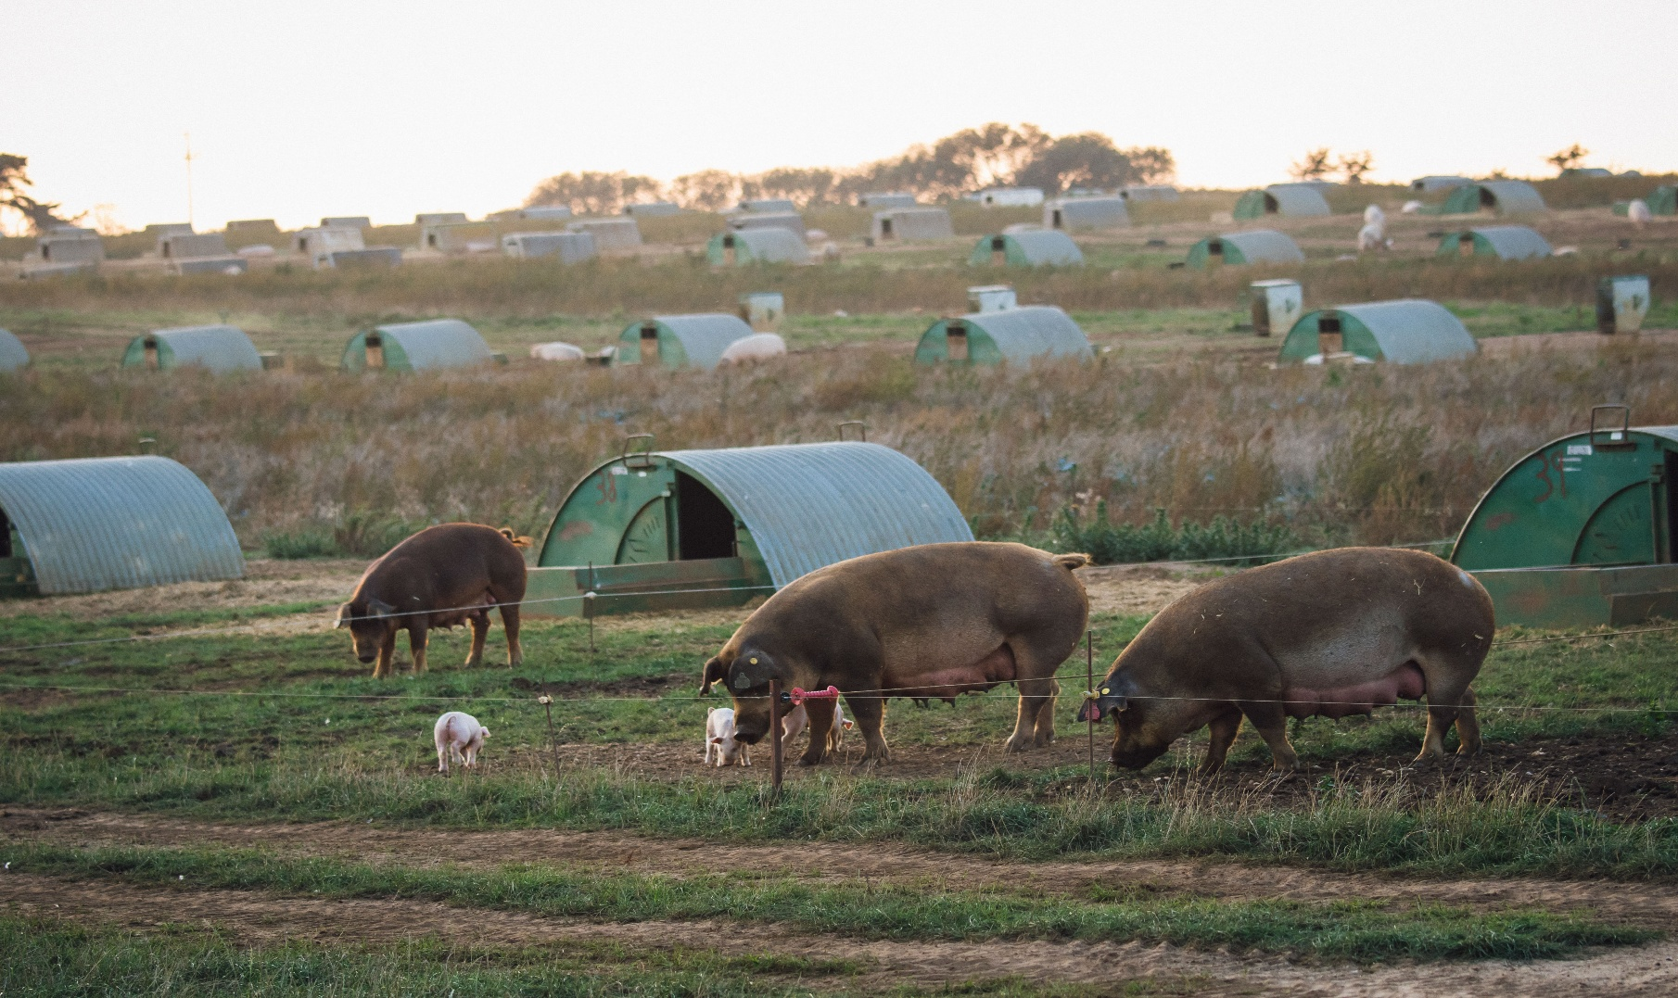
The British pork sector has made substantial progress in improving environmental performance over the past two decades, driven largely by industry-led gains in efficiency, productivity and innovation to produce affordable, high-quality British pork. Over the past two decades, emissions intensity has fallen by around 40%, one of the most significant proportional reductions across UK livestock sectors. British pork offers a relatively low carbon footprint compared to other meats, particularly when assessed at the farmgate and on a protein basis. Between 2008 and 2023, carbon emissions per kilogram of pork dropped by 18%, reinforcing pork’s role as a lower-emission protein source.

Further progress will require a more coordinated, whole-system approach. Key challenges remain around data consistency, measurement frameworks, adoption of new technologies, regulatory complexity and the integration of sustainability measures within commercially viable systems. Many pig enterprises operate as part of mixed farming systems, meaning that environmental outcomes – particularly for carbon, nutrients, biodiversity and water – must be addressed at whole-farm and supply-chain level, rather than by individual enterprises in isolation.
Feed remains the largest driver of environmental impact, with continued opportunities to reduce reliance on imported soya through improved feed efficiency, alternative proteins and circular feed systems. Across air quality, water stewardship, nutrient management, biodiversity, waste, energy and net carbon, the sector has demonstrated that environmental improvement and productivity are not mutually exclusive. Case studies show that well-designed interventions can deliver emissions reductions, cost savings and resilience benefits simultaneously.
Facilitated by AHDB, the roadmap provides a shared, evidence-based framework to coordinate action across the sector. The next phase of the roadmap therefore focuses on closing evidence gaps, scaling proven solutions, improving data governance and aligning policy and investment. This will enable the British pork sector to continue reducing environmental impact, strengthen resilience to climate and market pressures and demonstrate leadership in sustainable food production.

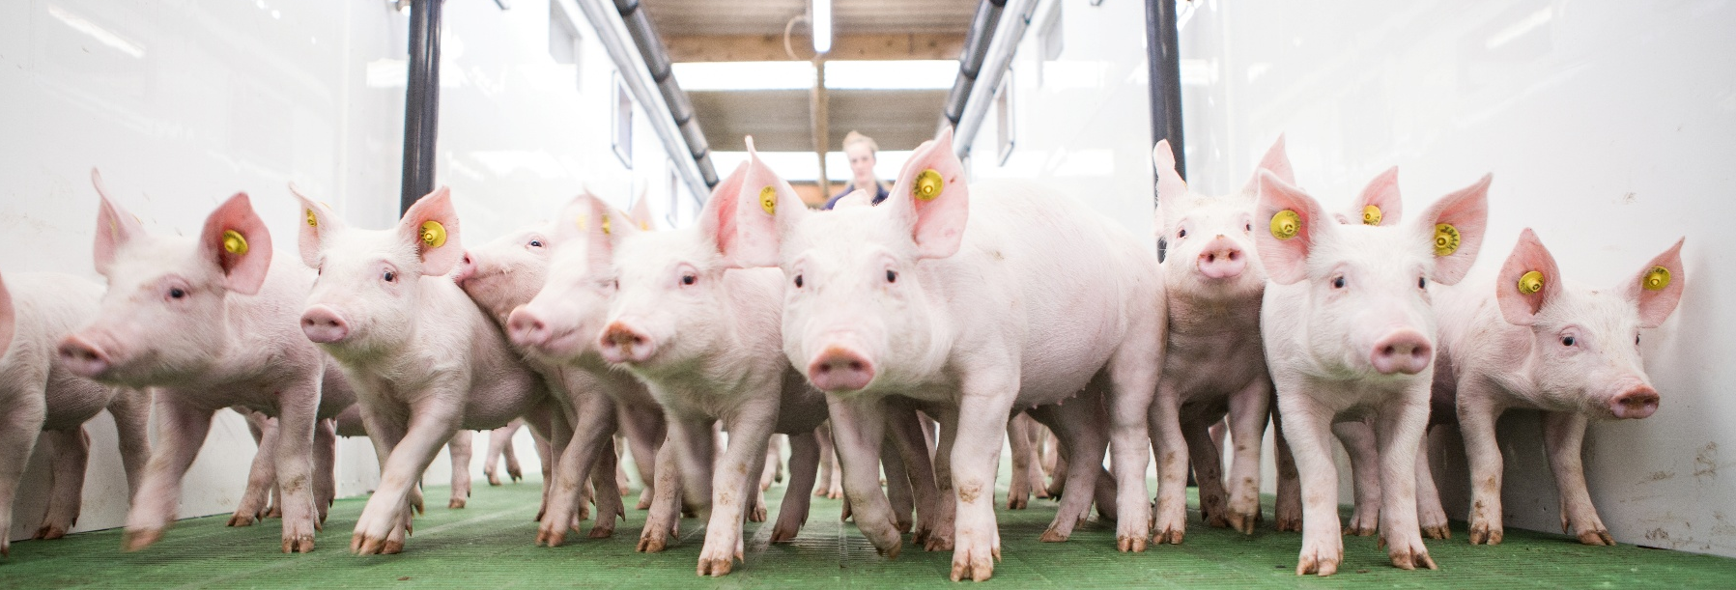

Foreword

It has been both an honour and a pleasure to chair the industry’s steering group during the development of this environmental roadmap for the British pig sector. The group has brought together a wide range of industry stakeholders, and throughout the process discussions have been rigorous, informed and constructive. From the outset, we were united by one clear principle: this roadmap must be led by evidence.
For that reason, we commissioned a new life cycle assessment (LCA) of prime pig production to farmgate. While this process has taken longer than initially anticipated, the steering group was unequivocal that accuracy must take precedence over speed. Earlier assessments have been strengthened with improved feed data to ensure the current picture is as accurate as possible.
The group has also been determined to make sure the latest data on emissions has been accessed.
The roadmap paints a transparent picture of where the UK pig sector is today with respect to its environmental impact. It highlights the substantial gains already achieved while identifying areas requiring further action. Importantly, this is not a static document; it will evolve, incorporating new data, case studies and emerging technologies to guide continued improvement.
Environmental sustainability is a shared endeavour. The steering group wishes to encourage engagement with all interested parties, and if there are challenges to our current conclusions, let’s hear about them! Constructive scrutiny strengthens credibility and drives progress.

Hugh Crabtree MBE BSc (Hons) FIAgrE, Pork Environmental Roadmap Chair


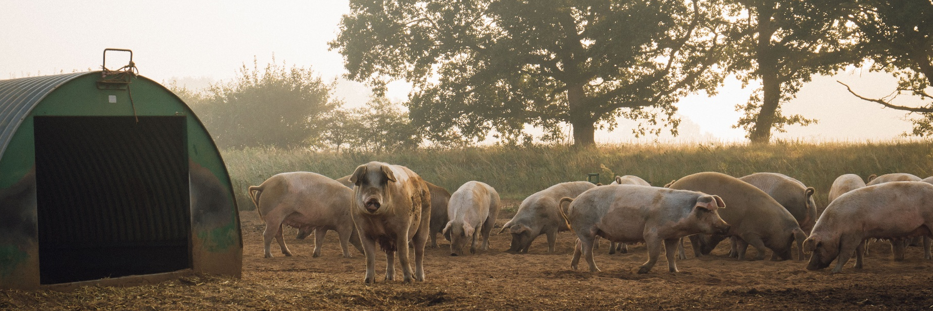

Introduction
Agriculture plays a central role in balancing environmental responsibility and global food security. Managing 70% of the UK’s land area, farmers are custodians of soils, water and biodiversity while adapting to the pressures of climate change. Their efforts also store millions of tonnes of carbon in soils, hedgerows and permanent vegetation, making farming systems critical to both emissions reduction and carbon sequestration.
To achieve a sustainable future, the world does not necessarily need to consume less meat. Instead, livestock production can be genuinely circular and self sustaining, with efficiency improvements allowing developed nations to reduce their emissions while enabling growing economies in Africa and Asia to expand livestock enterprises in a balanced manner.
Relative to 2009 level, the FAO estimates that global livestock productivity must increase by 1.7% each year if the world is to meet the projected need for 70% more food by 2050. Most of this growth is expected to come from regions such as the UK, where extreme weather will be least impactful and where livestock production is among the most sustainable in the world.

UK agriculture greenhouse gas emissions
In 2024, UK agriculture contributed 12% of the country’s greenhouse gas (GHG) emissions compared with transport (30%), buildings and product use (21%) and industry (13%) (Figure 1).
Agriculture is a major source of non-carbon dioxide emissions and is responsible for:
- 70% of nitrous oxide emissions, largely linked to fertiliser production and use and feed production
- 49% of methane emissions, predominantly from ruminant livestock
87% of ammonia emissions
In contrast, agriculture contributes only around 2% of UK carbon dioxide emissions, mainly
from the fuel and electricity used for machinery and buildings. This differs markedly from other sectors, where carbon dioxide dominates emissions profiles.
The pork sector accounts for 4% of the total UK agriculture emissions, primarily driven by nitrous oxide from feed production and fertiliser use, alongside nitrous oxide and methane from manure management.
Figure 1. UK greenhouse gas emissions by sector in 2024
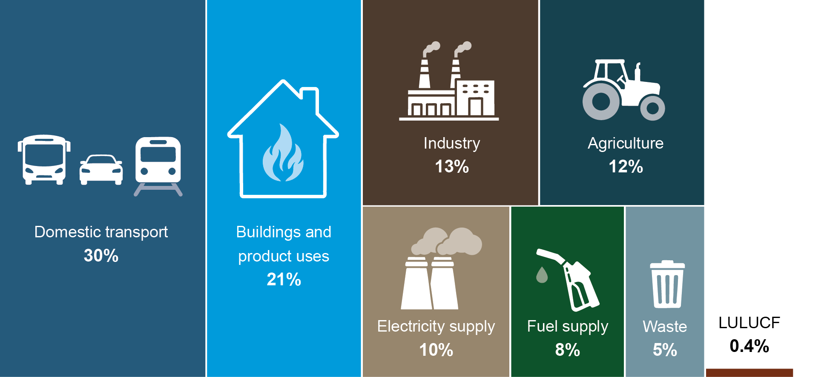
Source: DESNZ, 20242
Notes: LULUCF = Land use, land-use change and forestry. Estimates of agriculture, waste and LULUCF sector emissions for 2024 are largely derived from projections.

Net zero and the role of agriculture
The UK’s commitment to the Paris Agreement and its legally binding net zero target by 2050 requires emissions to be balanced by removals, rather than eliminated entirely. However, agricultural emissions are currently reported as gross emissions only, while many climate-positive activities undertaken by farmers such as tree planting, hedgerow management, soil carbon improvement and on-farm renewable energy generation are reported under other sectors (land use, forestry or energy). As a result, agriculture’s contribution to carbon sequestration and renewable energy generation is not reflected in headline emissions figures.
Achieving net zero in agriculture therefore requires a whole-system approach, tracking both emissions released (e.g. methane and nitrous oxide) and carbon removals through soils, biomass and land management. Understanding this net carbon position is essential for designing effective mitigation and adaptation strategies.

Lowering livestock emissions
Global demand for livestock products is projected to rise by 21% between 2020 and 2050, driven by population growth and rising incomes. While this creates economic opportunities, it poses challenges for limiting global temperature rise to 1.5°C.
Evidence from the FAO shows that dietary change alone delivers relatively modest emission reductions, whereas improvements in livestock productivity and efficiency offer the greatest mitigation potential (Figure 2). Prioritising livestock products from efficient, environmentally responsible systems, such as those in the UK, can therefore play an important role in global emissions reduction.
Figure 2. Pathway to lower livestock emissions
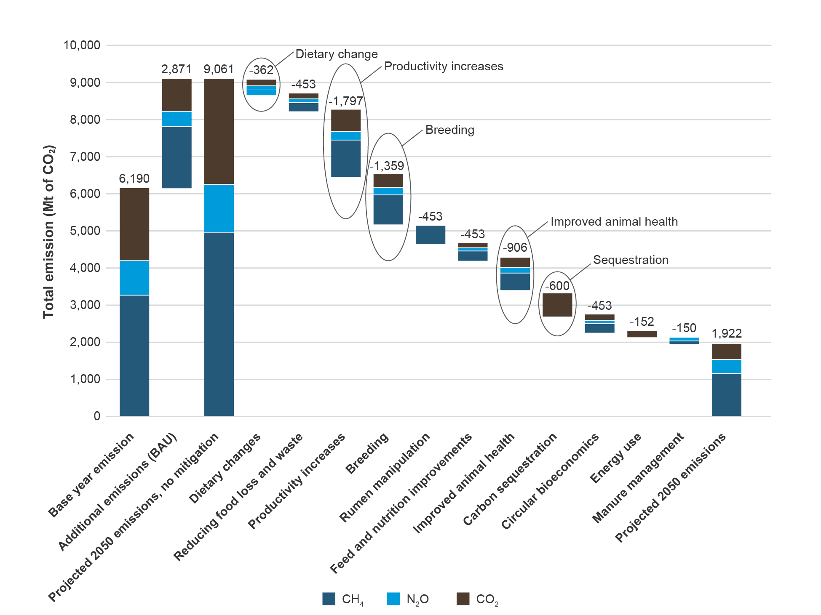
Source: FAO 20237

Overview of the British pork sector
The UK pig population has declined significantly, with 38% fewer pigs in 2024 than in 1990
(Table 1). In 2024, breeding pig numbers fell by 1.7%, while fattening pig numbers rose slightly (+0.9%), reflecting continued focus on productivity.
An estimated 50% of British pigs are outdoor bred, contrasting with indoor breeding and rearing practised in most European pig-producing countries. The sector is also highly integrated with strong coordination across breeding, feeding, rearing and processing, providing opportunities to manage resources efficiently and reduce environmental impacts.
The UK is not self sufficient in pig meat, producing 59% of domestic consumption in 2024, up from 55% in 2014. Imports therefore play a key role, particularly for carcase balance, as UK consumers favour certain cuts. Declines in domestic production increase reliance on imports, reducing control over environmental standards.
Despite a smaller breeding herd, pig meat production grew by 3.7% in 2024, driven by improved productivity and heavier carcase weights. Imports increased marginally (+0.7%), while exports fell slightly, indicating broadly balanced supply and demand.

Table 1. Number of pigs in the UK (in thousands)
Category | 1990  (‘000) | 2023  (‘000) | 2024  (‘000) | % change  2024/2023 | % change  2024/1990
Total pigs | 7,548 | 4,683 | 4,715 | 0.7% | -38%
Breeding pigs | 911 | 428 | 421 | -1.7% | -54%
Female breeding herd | 781 | 338 | 327 | -3.1% | -58%
Sow in pig | 503 | 238 | 236 | -0.8% | -53%
Gilts in pig | 110 | 48 | 42 | -11% | -61%
Other sows | 168 | 52 | 48 | -6.5% | -71%
Other breeding pigs | 130 | 90 | 93 | 3.7% | -28%
Boars being used for service | 44 | 10 | 9 | -3.8% | -78%
Gilts intended for first-time service | 86 | 80 | 84 | 4.6% | -3%
Fattening pigs | 6,637 | 4,255 | 4,295 | 0.9% | -35%
Source: Defra8

Climate change and sector resilience
The British pork sector has been proactively addressing its environmental impact well before sustainability became a global imperative. Nevertheless, climate change is reshaping production conditions and intensifying pressures on feed supply and costs. Key risks include:
- Feed and straw availability, affected by droughts and flooding
- Rising input costs, particularly for grain-based feeds
- Heat stress, which can reduce pig growth, fertility and health
Changing consumer demand influenced by weather-related purchasing patterns
Producers are responding through improved housing design, ventilation and cooling, enhanced feed efficiency and greater focus on resilience and locally sourced inputs.

Looking ahead
Over the past decade, the British pork sector has delivered substantial reductions in emission intensity while improving productivity. To meet future climate goals, maintain consumer confidence and secure its role in sustainable diets, the sector will continue to focus on efficiency-led mitigation, climate adaption and evidence-based improvements.
This roadmap builds on that foundation, setting out how British pig production can remain environmentally sustainable, economically viable and globally competitive in a changing climate.

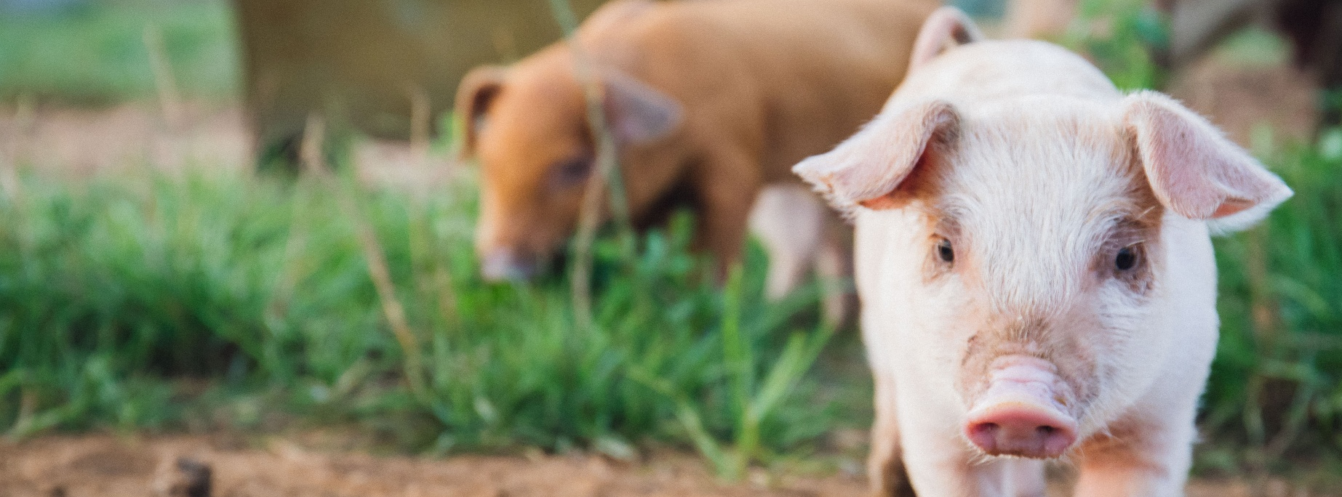

Pork Environmental Roadmap

Purpose
The industry-owned pork sector roadmap, facilitated by AHDB, outlines pathways to achieving net zero while maintaining food production and economic sustainability. It assesses the environmental impact of pig meat production up to farmgate, placing current challenges in the context of the sector’s long-standing progress in efficiency and sustainability.
The roadmap provides a shared platform to evidence and communicate environmental performance, bringing together stakeholders from across the pork supply chain. A core goal is to support the sector in protecting and promoting British pork in both domestic and international markets, positively differentiating it from products produced under less robust standards.

Objectives of the roadmap
The roadmap is designed to:
- Document historic progress in sustainability across British pig production.
- Evidence the current position by assessing the sector’s current environmental impacts using robust, transparent data.
- Define future ambitions and the actions required to achieve them.
- Leverage evidence to protect and promote the industry's reputation and inform on-farm decisions for continuous improvement.
- Identify research gaps and barriers, enabling collaboration across the sector to address shared challenges.
Together, these objectives reinforce the sustainability credentials of British pig production while fostering innovation and sector-wide cooperation.

Strategic priorities
The roadmap identifies seven interlinked strategic priorities to drive sustainability outcomes across the sector. These priorities align with the UN Sustainable Development Goals and reflect the need to address both climate adaptation and mitigation while balancing environmental, social and economic outcomes.
Strategic priorities are:
- Net carbon – Improve the sector’s carbon balance, including continued gains in feed efficiency.
- Air quality – Reduce ammonia emission to improve air quality.
- Water stewardship – Protect and sustain water resources.
- Slurry, manure and nutrient management – Optimise resource use and nutrient efficiency.
- Biodiversity and natural resource stewardship – Deliver positive outcomes for nature.
- Waste and recycling – Minimise waste and boost recycling efforts.
- On-farm energy – Improve energy efficiency and expand renewable energy use.

Underpinning success
While the priorities define the sector’s direction of travel, delivery depends on several cross-cutting actions:
- Establishing a standardised framework for measuring, verifying and reporting data
- Supporting the development and adoption of new technologies
Ensuring timely uptake of best practices as evidence and innovation evolve

Governance
The Pork Environmental Roadmap Steering Group provides strategic oversight, setting the scope and direction of the roadmap. The group brings together key stakeholders, including integrators, producers, industry bodies, levy organisations, an independent consultant and Red Tractor Assurance, working in partnership to ensure alignment with industry needs.
Their responsibilities include:
- Developing and overseeing implementation of the roadmap
- Agreeing priority areas and milestones
Identifying and coordinating actions to drive sustainability progress
This collaborative approach ensures that the roadmap is practical, evidence led and industry relevant, supporting the long-term sustainability and competitiveness of British pork production.

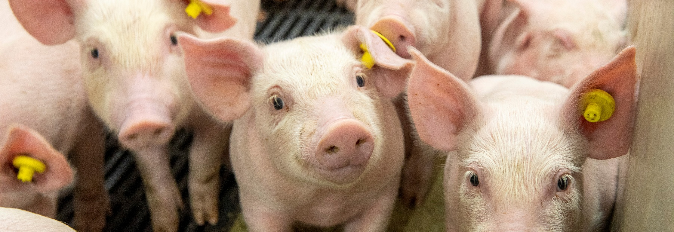
This section reviews and summarises the evidence and initiatives that the sector is championing to reduce its impact on the environment.

What is the sector already doing?

Life cycle assessment of British pork production
The life cycle assessment (LCA) for pork production provides a detailed picture of how different stages of the production system (feed, housing, manure management, energy use and land-use decisions) contribute to environmental impact. By assessing these impacts across internationally recognised categories, the LCA helps pinpoint where progress has been made and where further improvements are still possible. Figure 3 summarises the key impact categories used in the assessment, explains what each one measures and highlights the typical drivers within pig production systems.
Figure 3. Life cycle assessment impact categories in pig production
Impact category | What it means | Typical drivers in pig production
Climate change | Total  Emissions of CO₂, methane and nitrous oxide over a 100-year period. | Feed production, manure emissions, energy use.
Climate change | Land use and land-use change (LULUC)  Emissions released when natural habitats are converted into farmland. | Soya linked to deforestation  or habitat conversion.
Eutrophication | Freshwater  Phosphorus losses to rivers and lakes that can trigger algal blooms and reduce water quality and aquatic life. | Phosphorus from fertiliser used for feed crops and losses in run-off.
Eutrophication | Terrestrial  Nitrogen build-up on land (from ammonia and nitrate). | Ammonia from slurry, nitrate  leaching after manure spreading  and fertiliser use.
Acidification | Emissions that cause acid rain and soil damage, mainly from ammonia, sulphur dioxide and nitrogen oxides. | Ammonia from manure, sulphur dioxide and nitrates from feed production and energy use.
Resource use | Use of fossil fuel (coal, oil and natural gas) and the pressure this puts on future availability. | Fertiliser production, feed processing, on-farm heating and ventilation systems.
Resource use | Depletion of scarce minerals  and metals (e.g. phosphate rock,  iron and aluminium). | Phosphate fertilisers, mineral supplements, metals in machinery  and building.
Water use | Pressures that a farm’s water consumption places on local ecosystems. | Drinking systems, leaks, washing and cooling water as well as water used in the upstream life cycle of animal feed and fertilisers.

Table 2. Comparison of 2008, 2013, 2018 and 2023 life cycle assessment results – per kg of pork
Impact category | Unit | 2008 | 2013 | 2018 | 2023 | % change  2023/2008
Climate change, total | kg CO₂ eq | 3.88 | 3.94 | 2.98 | 3.20 | -18%
Climate change, land use and land-use change | kg CO₂ eq | 0.70 | 0.77 | 0.38 | 0.21 | -71%
Eutrophication freshwater | g P eq | 1.13 | 1.02 | 1.01 | 1.09 | -3%
Eutrophication terrestrial | mol N eq | 0.31 | 0.26 | 0.27 | 0.27 | -13%
Acidification | mol H+ eq | 0.08 | 0.07 | 0.07 | 0.07 | -11%
Resource use, fossils | MJ | 16.4 | 17.0 | 14.0 | 14.4 | -12%
Resource use, minerals and metals | mg Sb eq | 7.07 | 6.29 | 7.02 | 8.34 | 18%
Water use | m³ depriv. | 0.59 | 0.86 | 0.53 | 0.62 | 5%
Source: ERM, 2025

Progress since the last LCA

Climate change impacts
The total climate change impact increased slightly between 2008 and 2013, declined markedly by 2018 and rose again in 2023. Despite this recent increase, the long-term trend shows a clear reduction overall, with an 18% decrease since 2008. This reflects sustained improvements in the efficiency of British pig production. Over this period, productivity gains – including increased litter sizes, higher carcase weights, faster growth rates and improved feed conversion efficiency – have enabled more pork to be produced per unit of input, reducing emissions intensity across the system. A major contributor to this improvement has been a 71% reduction in emissions associated with land use and land-use change.
Emissions linked to land-use change increased slightly between 2008 and 2013, followed by a substantial and sustained decline through 2018 and 2023. This represents the strongest long-term improvement, with a 71% reduction since 2008. This has been driven primarily by changes in feed sourcing and formulation, with deforestation-free soya used in pig diets and increased use of food industry co-products such as wheatfeed, biscuit meal, distillers’ grains and rapeseed meal. As these materials are by-products of existing manufacturing processes, they require no additional land, fertiliser or irrigation, substantially lowering their environmental burden.
These feed-related improvements have been reinforced by wider system efficiencies. Advances in genetics and herd health, more efficient housing and ventilation, improved manure-to-land management, and gains in on-farm energy efficiency have each delivered incremental benefits. While modest in isolation, together these changes have driven a meaningful reduction in the overall carbon footprint of British pork production.

Nutrient, resource and water-related impacts
Trends in nutrient-related impacts show steady improvement. Freshwater eutrophication has remained broadly stable over time, with a small reduction of 3% since 2008. Terrestrial eutrophication has also remained relatively stable overall, falling by 13% between 2008 and 2023. Acidification decreased between 2008 and 2013 and has remained stable since, reflecting sustained improvements in nutrient and emissions management.
Fossil resource use has declined by 12% since 2008, reflecting improvements in energy efficiency across feed production, processing and on-farm operations, as well as a reduced reliance on fossil energy per unit of pork produced. In contrast, the resource use category for minerals and metals has increased by 18%. This trend is primarily driven by changes in feed composition over time. The inclusion of barley relative to wheat in pig diets has contributed to higher demand for phosphorus-based fertilisers as barley typically requires greater phosphorus inputs per unit yield. Phosphorus fertilisers are derived from phosphate rock, a finite mineral resource that is heavily weighted within the minerals and metals impact category.
Additional contributions arise from the production of synthetic amino acids (e.g. lysine, methionine) and trace mineral supplements, which rely on the extraction and processing of mineral resources. Importantly, increases in minerals and metals impacts do not necessarily indicate reduced sustainability; they can also reflect greater use of formulated feeds and precision nutrition strategies that improve feed efficiency and reduce other environmental impacts, highlighting the importance of understanding trade-offs across impact categories.
Water use shows a small increase of 5% between 2008 and 2023. This change is linked to shifts in feed composition and the geographic sourcing of key ingredients, including UK-produced grains and specific amino acids. Overall, water use has remained relatively stable across the period, reflecting broadly consistent sourcing patterns and production practices in major feed-supplying regions.

The bigger picture
Environmental performance is not driven by on-farm activity alone. It is also shaped by how effectively the wider supply chain (trade, processing, labour availability and market access) functions to support biological efficiency on farm.
The lowest climate change impact in the LCA was recorded in 2018, reflecting favourable feed composition alongside strong system performance during that period. From 2019 onwards, a series of external shocks disrupted the British pork sector. These included COVID-19, Brexit and changes in global trade dynamics, particularly with China. Pig meat production has shown a gradual long-term increase, but between 2021 and 2023 production fell by 10.9%. This reflected a combination of pandemic-related demand changes, reduced exports to the Chinese market, supply chain disruption linked to carbon dioxide availability, and shortage of labour in pork processing plants. Together, these pressures created an oversupply of pigs and negative margins for producers.
The labour shortage that followed post-Brexit immigration changes was particularly significant, it represented a profound shock to the industry and should not be understated. Reduced availability of EU labour across farms, abattoirs and processing plants led to sustained capacity constraints. This in turn, resulted in on-farm backlogs, increased slaughter age and liveweight, and the introduction of temporary derogations on stocking density to safeguard animal welfare. Collectively, these factors reduce overall system efficiency, increasing feed use, energy demand and manure volumes per pig produced and driving a short-term rise in several environmental impacts indicators.
From 2021 onwards, reduced availability of co-products, particularly liquid co-products added further pressure. Expansion of biogas plants, supported by government incentives, increased competition for these materials, as energy producers were often able to pay more for them and pricing the pig sector out of the market. This has unintended consequences for the pig sector, increasing reliance on meal-based feeds and influencing resource-use profiles.
At the same time, it is important to recognise the strength of domestic supply chains. The sector makes substantial use of UK-grown cereals and rapeseed meal, contributing to circularity within British agriculture and reducing dependence on imported ingredients.
As processing capacity recovered and backlogs were cleared, climate change performance indicators in 2023 began returning towards pre-disruption levels seen in 2017–18. This suggests that the temporary increase in climate change impacts from 2019 and 2022 reflected operational constraints rather than structural regression in farming practices.
Overall, the LCA demonstrates that sustained efficiency gains across British pig production have delivered substantial environmental benefits. At the same time, it highlights the importance of system resilience in maintaining environmental performance during periods of economic and policy instability.

The fine balancing act in LCAs
An LCA does not assess environmental effects in isolation. It evaluates several impact categories simultaneously, each influenced by different biological, chemical and management processes. This means that an action which improves one impact may increase pressure elsewhere. This is not a flaw in the methodology – it reflects the interconnected nature of modern pig production systems and the trade-offs that inevitably arise when managing complex biological systems. A few examples which illustrate how these interactions play out include:
- Lowering crude protein in pig diets reduces nitrogen excretion and ammonia emissions, improving both acidification and terrestrial eutrophication. However, maintaining performance may require additional cereals or specific amino acids which can increase mineral resource use or fossil energy demand in the feed supply chain
- Better building insulation reduces heating needs, lowering fossil resource use and climate emissions. At the same time, the additional construction materials can increase embedded mineral and metal resource use
Frequent slurry removal reduces ammonia emissions, improving air quality and nutrient loading. Yet if the slurry is stored for longer before spreading, methane production can increase in storage, adding to climate change impacts

Turning evidence into action
The value of LCA lies in its ability to make trade-offs visible. By providing a multidimensional view of environmental performance, it supports whole-system thinking and helps identify where the most meaningful improvements can be made. The presence of trade-offs is not a sign that progress is impossible; rather, it reflects the reality that no single action can optimise every impact category at once.
Real progress seldom comes from a single ‘silver bullet’. Instead, it is achieved through combinations of actions that collectively reduce the overall footprint, even if some individual indicators move in different directions. The task for the sector is to identify and prioritise those combinations that deliver the greatest net environment benefit while managing any associated downsides.
By highlighting both improvements and pressures, the LCA provides the evidence base needed to guide decision making and ensure the future interventions deliver balanced and credible sustainability gains for British pig production.

Net carbon
Achieving carbon balance on pig farms requires a combination of carbon sequestration, emissions reduction and sustainable farming practices. While pig production contributes to GHG emission, there are opportunities to offset these through soil management, feed efficiency and manure handling. A net-carbon approach considers both GHG emissions and carbon removals together, providing a more complete picture of a farm’s true climate impact. This is essential for understanding progress, guiding decision making and recognising the full contribution of pig farming systems.

Recognising carbon sequestration on pig farms
Current GHG reporting frameworks do not fully reflect carbon sequestration occurring on pig farms. Under National GHG Inventory rules, carbon removal activities such as woodland creation and soil improvement on farms are recorded separately under land use and land-use change and forestry (LULUCF) rather than being credited to the farming sector itself.
Similarly, carbon footprint calculations often focus solely on emissions, failing to incorporate carbon sequestration or removals. Where sequestration is included, estimates are often based on broad international averages rather than farm-specific data, overlooking the integrated benefits of mixed and holistic farm systems.
GHG emissions and carbon removals must be assessed together to provide a singular net-carbon position. This balanced reporting approach will empower farmers to make informed land management decisions, provide due recognition and reward for sequestration efforts and ensure a transparent and credible framework for sustainability progress. However, meaningful net-carbon accounting depends on having a robust baseline.
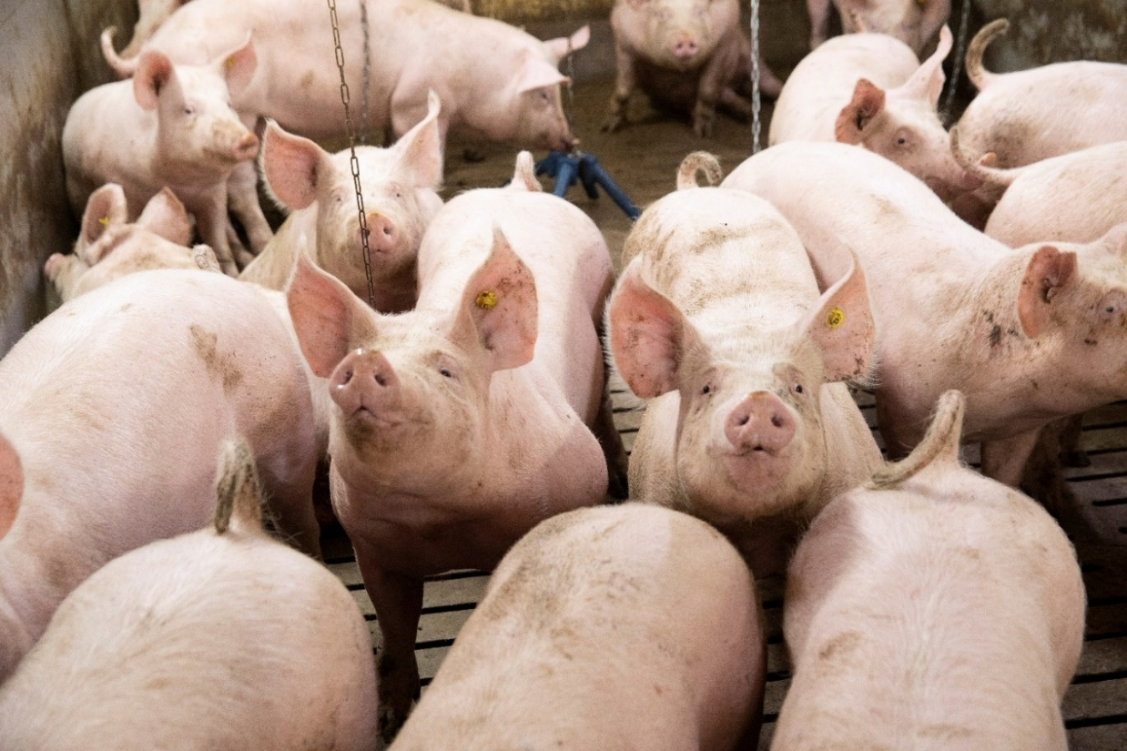

Industry initiative
Environment Baselining Pilot
The AHDB-led initiative is currently delivering a pilot baseline project across 170 farms in GB, including pig farms, to capture accurate farm-level data on carbon stocks and emissions. To demonstrate genuine change, the baseline measurement must be repeated every five years, recognising that carbon stored in the landscape is dynamic and can be both increased and lost over time.
The findings will provide the sector with accurate on-farm environmental data, reducing reliance on national and international averages. This will strengthen understanding of the role British agriculture plays in reducing emissions, building soil carbon, improving soil health and supporting biodiversity. It will also enable farmers to take insight-led action towards a more sustainable future.
Read more at: Environment Baselining Pilot | AHDB

Carbon footprint of British pork
Pork farming accounts for only 4% of the total UK agriculture emissions. Pigs have delivered the largest proportional reduction in emissions intensity (GHG emissions from producing a kg of pork) of any major livestock sector since 1990. Between 1990 and 2022, emissions intensity fell by 46%, driven by a 41% reduction in animal emissions and 10% increase in pig meat production.
At farm level, four main drivers influence emissions: feed (66%), slurry/manure (22%), housing (8%) and electricity (4%) (Figure 4).

Figure 4. Drivers of pork’s carbon footprint in 2023
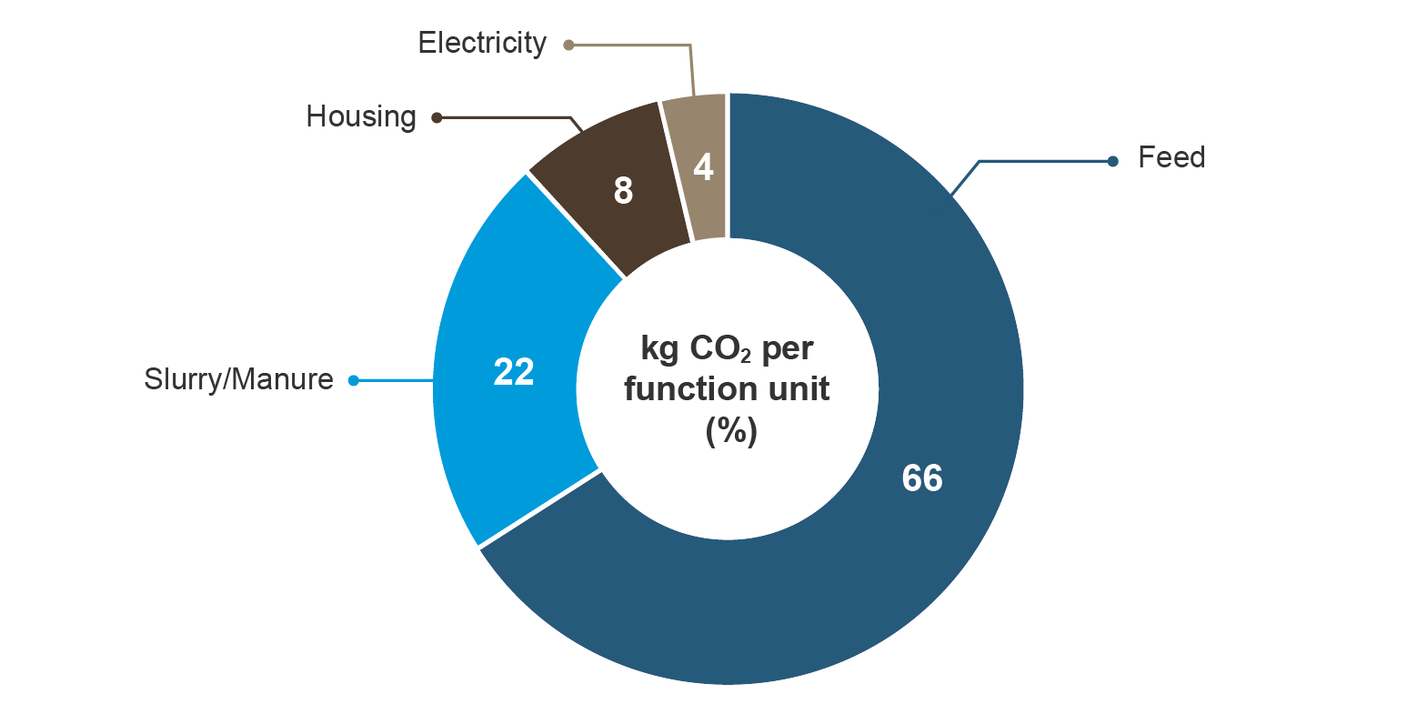
Source: ERM, 2025

British pork in a global context
Discussions around meat carbon footprints often rely on global averages, which can mask significant regional differences in production systems. Factors such as genetics, animal health, housing, feed sourcing, climate and resource availability all influence emissions outcomes. As a result, global averages are rarely representative of British pork production. This underlines the importance of using locally derived, primary data modelled to IPCC Tier 3 standards when assessing the British pig sector. Available data show that:
- At retail shelf, British and global footprints are broadly similar (11.5 vs 12.3 kg CO₂e/kg deadweight) (Figure 5)
At farmgate, British pork has a significantly lower footprint than the global average (4.96 vs 9.0 kg CO₂e/kg) (Figure 6)
Further evidence shows that between 1990 and 2021, the British pig industry reduced its global warming potential (GWP) by 37% in the indoor sector and 35% outdoors, largely due to higher growth rates and improved carcase, which reduced overall energy requirements.
Figure 5. Meat gross emissions cradle to retail per unit of output GWP100 (kg CO₂e/kg product)
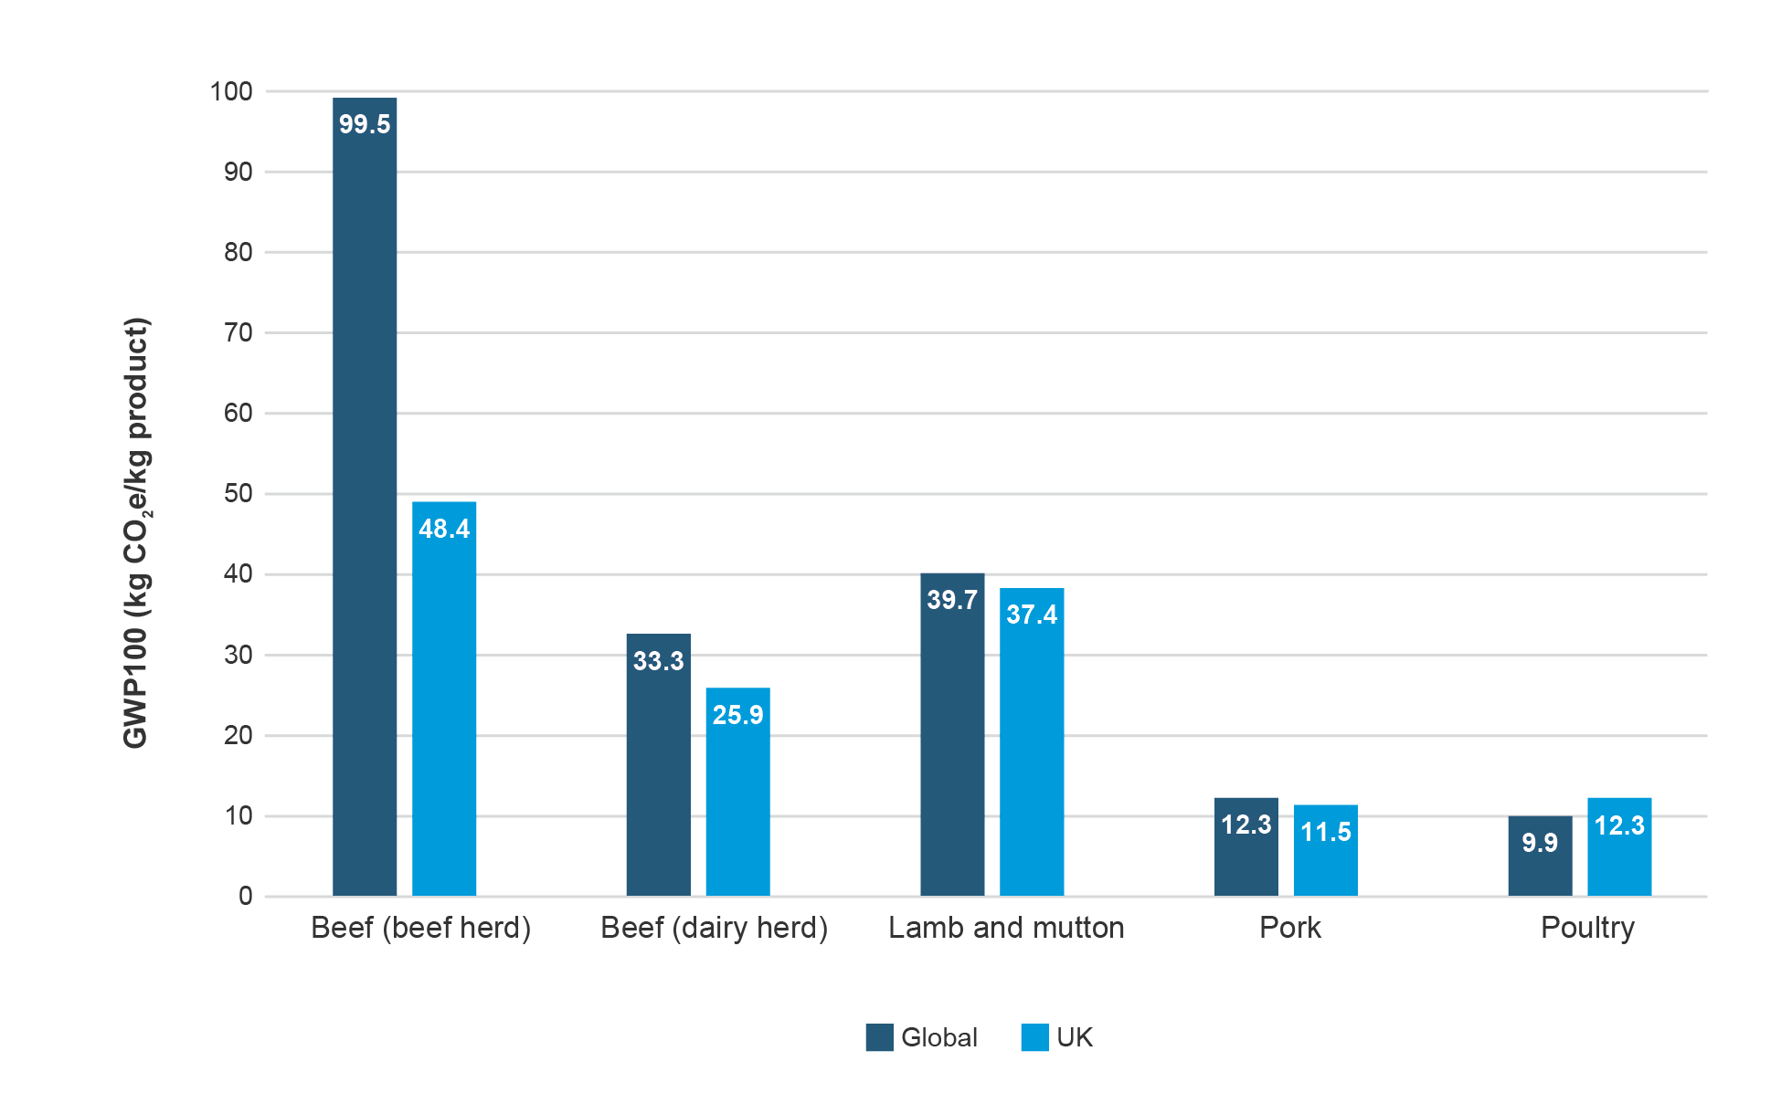
Source: Poore and Nemecek, 201816, a study published in science in 2018. There are limited data points in each respective data set, and they are more limited in the country data set.
Figure 6. Meat gross emissions cradle to farmgate per unit of output GWP100 (kg CO₂e/kg product) excluding carbon sequestration
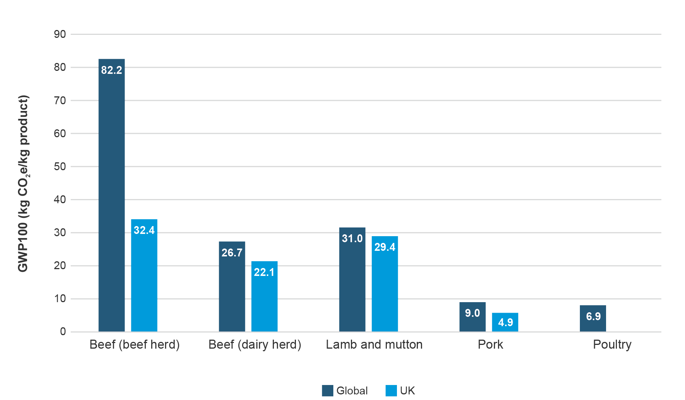
Source: Global data uses Poore and Nemecek, 201816; UK data uses Agrecalc, carbon and efficiency calculator; data from farms with applicable enterprises 2018–2022, AR4 GWP. Mean gross emissions only, emissions to farmgate as CO₂e/kg deadweight and CO₂we/kg deadweight. Not available for poultry.

Protein content of pork in relation to the carbon footprint
Carbon footprints are most commonly expressed per kilogram of product. However, there is growing interest in assessing food on both their environmental impact and their nutritional value. This includes considering emissions in relation to the amount and quality of protein a food provides, rather than weight alone. While this approach is still evolving, it offers useful additional context when comparing foods with very different nutritional profiles.
Recent work has highlighted the opportunities, but also the challenges of integrating environmental and nutritional assessment within life cycle assessment. Protein-based functional units can help provide a more meaningful comparison between foods, particularly where protein quality is also taken into account. The FAO has explored carbon footprints based on protein provision, for example per 100g of protein, adjusted for protein quality.
On this basis, pork performs relatively well. Global average emissions for pork are estimated at 7.6 kg CO₂e per 100g of protein, making it the second lowest among the major meat categories, behind poultry (Table 3). This suggests that, when protein provision is considered alongside emissions, pork compares favourably with many other meat options.
Table 3. GHG emissions on a protein basis (kg CO₂e /100g protein)
Beef  (beef herd) | Lamb  and mutton | Beef  (dairy herd) | Pork | Poultry
49.9 | 19.9 | 16.9 | 7.6 | 5.7
Source: Poore and Nemecek, 2018. There are limited data points in each respective data set, and
they are more limited in the country data set.

Greenhouse gas mitigation options
Reducing emissions intensity (the amount of GHG emitted per unit of pork meat produced) remains central to lowering the sector’s overall footprint. Evidence suggests:
- Up to 25% reduction in emissions intensity by 2050 relative to 2021 through changed farming practices
A further 30% reduction potential from green fertiliser and avoided land-use change, particularly through feed sourcing
The Defra Farm Practice Survey 2024 highlights growing engagement with GHG reduction among pig and poultry producers17:
- 40% consider GHGs fairly important in decision-making
- 11% view them very important
48% are already taking action to reduce farm emissions
This demonstrates a strong commitment within the sector to integrate sustainability, with nearly half of producers actively working to curb emissions.

Marginal abatement cost curves for the pork sector
Marginal abatement cost curves (MACCs) provide a structured way to assess the cost-effectiveness of GHG reduction measures in agriculture, including pork production. They show how much emissions can be reduced by different interventions and at what cost, helping to identify where the greatest abatement can be achieved for the lowest financial impact. MACCs are widely used by governments and policymakers to inform climate policy and investment decisions.
Defra last published a MACC for UK agriculture in 2021 and a new MACC is currently under development. In 2024, IGD and WRAP published the first pork-sector-specific MACC, providing more detailed insight into emissions abatement options.5
The analysis estimated a total abatement potential of 0.5 MtCO₂e from changes in farming practices across the pork sector. Of this, approximately 0.2 MtCO₂e could be delivered through cost-saving measures, while 0.3 MtCO₂e would require additional investment (Table 4).
These findings highlight that meaningful emissions reductions are achievable, particularly through efficiency-led measures, while also highlighting areas where financial or policy support may be required to enable uptake.
Table 4. A list of the abatement options split by those that are cost saving and those that are an additional cost from the pork sector MACC
Cost saving | Additional cost
Soil compaction  Reducing N excess  Soil pH  Variable rate nitrogen  Improved drainage  Anaerobic digesters | Impermeable slurry cover  Cover crops  Nitrification inhibitor  Urease inhibitor  Improved crop nitrogen efficiency  Pig health  Slurry acidification  Triticale  Biogas flaring
Source: IGD 20245

Reducing feed-related emissions in British pig production
Feed represents the largest economic and environmental cost in production, making ingredient selection and formulation critical levers for reducing emissions. Beyond its role in animal health, welfare and productivity, feed strongly influences farm profitability and environmental impacts, particularly GHG emissions, land use, fossil energy demand and water quality.
Feed accounts for around two-thirds of production costs and over half of on-farm GHG emissions. As a result, the sector’s approach to reducing feed-related emissions focuses on two core strategies:
- Improving feed efficiency so less feed is needed to produce the same output
Lowering embedded emissions of feed itself through alternative ingredients and optimised formulations
Progress in feed efficiency is already evident (Figure 7 and Table 5). Between 2010 and 2022, average growth rate from weaning to slaughter increased from 778g/day to 885g/day, an increase of 13.8%. Over the same period, feed conversion ratio improved from 2.94 to 2.75, meaning around 6.7% less fed was required per kilogram of gain. Together, these trends show that pigs are growing faster and converting feed more efficiently.
Feed conversion ratio (FCR) is a key indicator of both productivity and environmental efficiency in pig production. It measures the amount of feed required to produce one kilogram of pig liveweight gain. A lower FCR indicates that pigs are converting feed more efficiently, which can reduce greenhouse gas emissions per unit of output while improving productivity. The most positive outcome is a falling FCR alongside maintained or improved carcase weights, showing that pork is being produced more efficiently without reducing output.
These gains, together with higher slaughter weights, reflect a combination of genetic progress, improved feeding strategies and the increased use of alternative feed ingredients, all contributing to a more efficient and lower-emissions production system.
Figure 7. Growth rate and feed demand
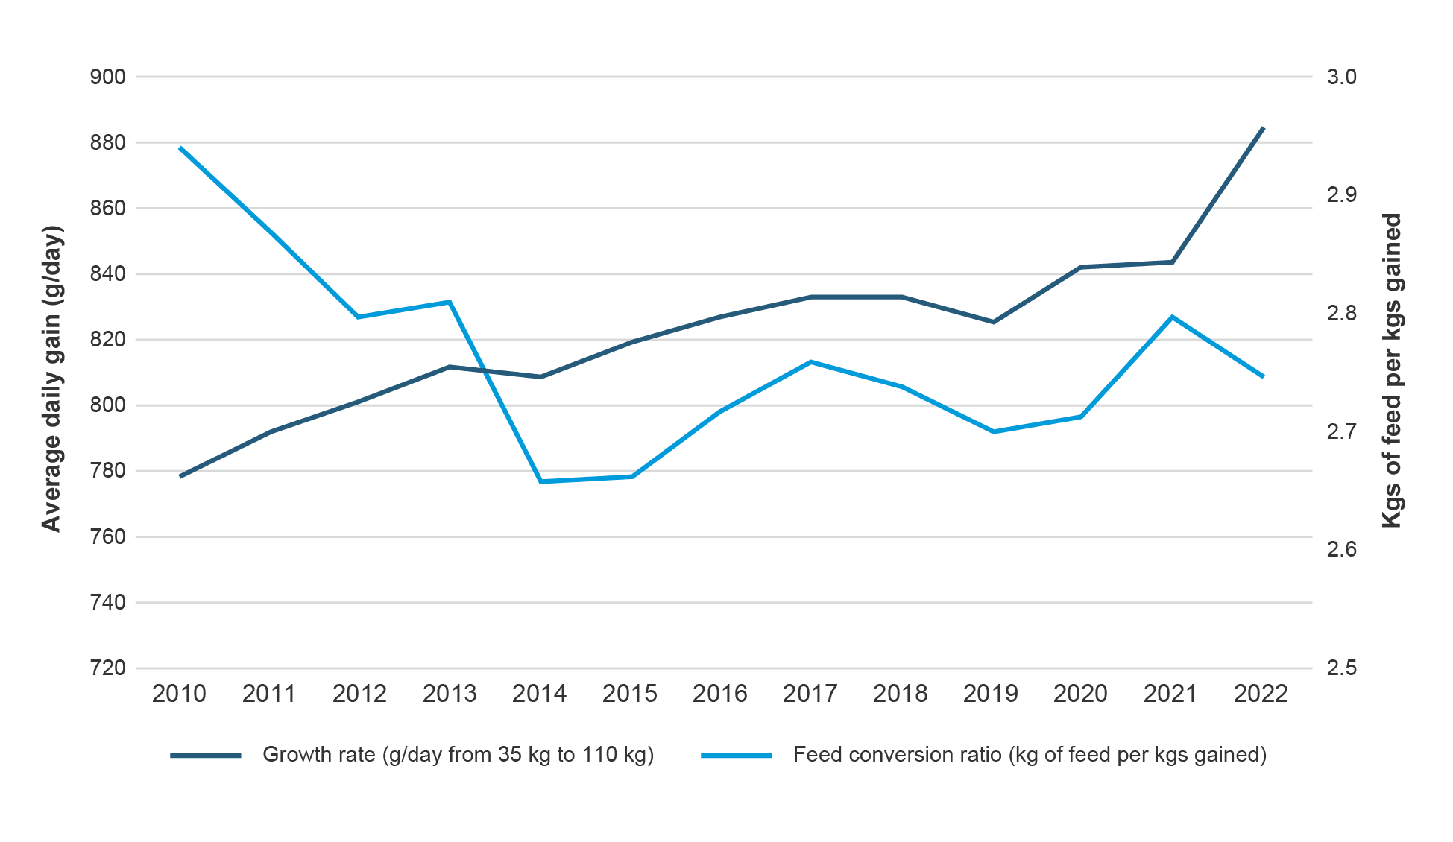
Source: Agrovision. Feed conversion ratio (FCR) is a key indicator of both productivity and environmental efficiency. A lower FCR indicates more efficient conversion of feed into output.

Table 5. Daily liveweight gain (DLWG), feed conversion ratio (FCR) and carcase weight of the finishing herd (35–110kg) from 2010 to 2022
Year | DLWG (g/day) – average | Feed conversion ratio – average | Feed conversion ratio – top 1/3 | Feed conversion ratio – top 10% | Carcase weight per pig (kg) – average
2022 | 885 | 2.75 | 2.26 | 1.83 | 90.7
2021 | 844 | 2.79 | 2.44 | 2.22 | 85.9
2020 | 842 | 2.71 | 2.24 | 2.01 | 84.2
2019 | 825 | 2.7 | 2.22 | 1.97 | 83.5
2018 | 833 | 2.73 | 2.45 | 2.31 | 83.1
2017 | 832 | 2.75 | 2.47 | 2.26 | 82.7
2016 | 826 | 2.71 | 2.36 | 2.15 | 82.1
2015 | 818 | 2.66 | 2.42 | 2.3 | 82.2
2014 | 808 | 2.65 | 2.36 | 2 | 80.4
2013 | 812 | 2.81 | 2.38 | 2.29 | 76.5
2012 | 801 | 2.79 | 2.5 | 2.21 | 77.8
2011 | 791 | 2.86 | 2.5 | 2.28 | 78.6
2010 | 778 | 2.94 | 2.68 | 2.8 | 79.6
Source: AgroVision

Responsible sourcing of soya
The British pork sector uses 360,000 tonnes of soya bean meal each year, making it the second-highest user in UK livestock production after poultry. The majority of imports originate from Argentina, Brazil and the USA (Table 6).20
Over the past decade, pig producers have developed a more precise understanding of soya requirements at different stages of growth, enabling better ration formulation. As a result, soya use across the sector has reduced, reflecting significant progress in reducing reliance on high-risk imported protein sources.
Producers have achieved this by incorporating alternative proteins, including beans, peas, co- and by-products from the food industry. Where soya remains necessary, the sector has focused on improving sourcing standards to minimise environmental risk. By 2024, an estimated 84.7% of soya was verified deforestation- and conversion-free (vDCF), up from 56.7% in 2019.20 This includes soya covered by zero deforestation standards, the Amazon Soy Moratorium, or sourced from regions with no deforestation risk, such as the USA and Canada. The status of the remaining 15.3% has not yet been established.
Despite this progress, challenges remain. Low global soya prices can make it harder for producers to justify switching to alternative protein sources, which may be less economically competitive. In addition, removing soya from lactating sow diets remains particularly difficult due to its high digestibility and favourable essential amino acid profile, which supports sow condition and piglet performance.
To address these challenges, the sector continues to explore new protein sources, refine diet formulation and invest in nutrition research, with the aim of further reducing reliance on soya.
Table 6. UK imports of soya beans (% of total UK soya bean meal equivalent imports)
Country | 2008 | 2013 | 2018 | 2019 | 2020 | 2021 | 2022 | 2023 | 2024
Argentina | 30 | 33 | 39 | 40 | 46 | 48 | 33 | 35 | 46
Brazil | 49 | 22 | 1 | 20 | 16 | 18 | 23 | 24 | 24
USA | 3 | 12 | 12 | 8 | 7 | 7 | 10 | 16 | 9
Paraguay | 0 | 0 | 1 | 2 | 0 | 0 | 0 | 0 | 0
Canada | 1 | 4 | 27 | 6 | 5 | 6 | 3 | 3 | 5
China | 1 | 1 | 2 | 2 | 1 | 0 | 1 | 1 | 1
India | 0 | 0 | 0 | 1 | 1 | 2 | 1 | 0 | 0
Other | 16 | 27 | 18 | 22 | 25 | 18 | 29 | 21 | 15

Source: HRMC. Where beans are supplied to the UK market, the soya bean meal equivalent is used to express import volume calculated as 72.5% yield.

Industry initiative
UK Roundtable on Sustainable Soya (UKRSS)
The UK Roundtable on Sustainable Soya (UKRSS) was established in 2018 to provide an open, collaborative forum for UK industry to work together towards a secure, resilient supply of deforestation-free soya. The roundtable brings together more than 30 members including major supermarkets, processors, farming organisation, feed business, foodservice business and soya traders. The UKRSS also publishes regular progress data, providing transparency on the UK’s transition towards sustainably sourced, deforestation-free soya and enabling industry-wide tracking of improvement.
Read more here: The UK Roundtable on Sustainable Soya – Efeca

Industry initiative
UK Soy Manifesto
In 2021, the UK Soy Manifesto was launched, setting out clear requirements for delivering deforestation- and conversion-free soya to the UK. Fifty signatories, including major pork processors and retailers, have committed to ensuring that all soya used in the UK supply chains is deforestation- and conversion-free by 2025.
Read more here: The Manifesto | The UK Soy Manifesto

Replacing soy in pig diets and the role of alternative feeds
Over the past decade, the proportion of soya used in pig feed has halved, falling from around 20% to approximately 10%. This reduction has been driven by improvements in feed efficiency, more precise diet formulation and increased use of alternative protein sources such as rapeseed meal, sunflower meal, distillers’ grains and other co-products from industries such as brewing, baking and potato processing. Many co-products carry a low attributed carbon footprint because their environmental burdens are largely allocated to their primary product, making them a lower-emission feed option. Increased use of locally sourced ingredients reduces transport-related emissions.
Grain legumes, particularly peas and fava beans, can provide effective protein sources in grower and finisher diets, contributing both protein and energy while improving crop rotations and nitrogen use efficiency in arable systems. Historically, concerns about palatability, digestibility and growth performance limited the use of peas and beans in pig diets. However, research has demonstrated that high inclusion levels of legumes do not compromise growth performance when diets are nutritionally balanced, including through the use of amino acid supplementation.
Modern feed formulation is now based on net energy and standardised ileal digestible amino acids, rather than older digestible energy systems. This has significantly expanded scope for replacing soya without detrimental effects on animal performance. While some feed producers apply processing techniques or additives to improve digestibility and reduce anti-nutritional factors, effective rations can also be formulated using straight peas and beans, depending on production stage. International comparisons highlight the potential for greater uptake of home-grown legumes. On-farm feed use accounts for around 70% of fava bean production in Germany, 25% in France and 15% in the UK and Spain.
It is also important to recognise that soya itself is a highly processed ingredient, requiring thermal treatment and oil extraction to address anti-nutritional factors such as trypsin inhibitors. Alternative proteins should there be assessed on a like-for-like basis. Research is ongoing into novel proteins, such as insects, algae and single cell proteins. However, these technologies remain at an early stage of commercial development and would require significant investment to scale. While insect protein is approved in pig feed in the EU, current UK regulations do not permit its inclusion, and discussions are ongoing regarding potential policy alignment.
Evidence also highlights important trade-offs; a 2025 LCA found that insect-processed protein could have climate impact up to 13 times higher than soya, raising questions about its role as a genuinely sustainable alternative.

Government and Industry Initiative
Nitrogen Efficient Plants for Climate Smart Arable Cropping Systems (NCS)
This four-year research initiative funded by Defra’s Farming Innovation Programme launched in March 2023. It aims to cut greenhouse gas emissions by replacing up to 50% of imported soya bean meal in British livestock diets with home-grown pulses and legumes, grown across 20% of the UK arable rotation.
For the pig sector, the project is exploring the role of fava beans as a lower-carbon protein source. Early results show that post-harvesting processing improves the nutritive value of fava beans, increasing their suitability for inclusion in pig diets.
Read more here: Nitrogen Climate Smart (NCS) Home Page – The NCS Project

Precision feeding to improve efficiency and reduce waste
Precision feeding aims to precisely match nutrient supply more closely to pigs’ nutritional requirements, taking account of age, weight and performance. By tailoring diets more accurately, nutrient utilisation is improved, and waste – particularly nitrogen excretion – is reduced.
In the UK, individual precision feeding is already widely practised in the farrowing sector, where sow diets are routinely adjusted according to parity, body condition and reproductive performance. The greatest opportunity for further gains lies in the adoption of precision group feeding on growing and finishing units.

Air quality
Ammonia emissions from agriculture arise mainly from the breakdown of nitrogen in livestock urine and faeces, as well as from the application of nitrogen fertilisers. In pig farming, ammonia is the dominant acidifying emission at farm level, whereas sulphur dioxide and nitrogen oxides are more strongly associated with upstream feed production and downstream processing.
Agriculture accounted for 87.1% of total UK ammonia emissions in 2023, with emissions falling by 17.6% since 1990 and by 3.1% since 2005. Pigs contribute approximately 6.4% of agricultural ammonia emissions in 2023, with long-term reductions driven by lower pig numbers, improved nitrogen use efficiency, advances in animal productivity, better manure management and the uptake of ammonia abatement techniques (Table 7).
However, recent data indicate that this downward trend has levelled off, indicating that further reductions may require new mitigation strategies. These include tighter control of emissions at source, improved manure handling and storage, and innovative housing and feeding strategies that reduce nitrogen losses before they occur.
The UK government has set a target to reduce ammonia emissions by 16% by 2030, relative to 2005 levels. In 2022, cattle accounted for around two-thirds of agricultural ammonia emissions, followed by poultry and then pigs (Table 8). Year-to-year variation in emissions continues to be influenced by factors such as weather conditions, fertiliser use and livestock numbers.

Regulatory framework and best practice
Under the Environmental Permitting Regulations (EPR), pig units with more than 2,000 pigs over 30 kg liveweight or more than 750 sows are required to hold an environmental permit. These farms must comply with best available technique (BAT) and associated emissions levels (AELs), which set benchmark standards to control ammonia emissions.
Permitted farms are required to implement best practice management and infrastructure standards, including:
- Optimisation of dietary protein levels
- Housing design that limits emissions
Effective slurry storage and handling systems
Beyond permitted farms, the Government’s Clean Air Strategy (2019) mandates that all slurry and digestate stores in England must be covered, helping to reduce ammonia losses and improve air quality more widely.

Mitigation measures and emerging solutions
Recent advances in slurry and feed management demonstrate substantial potential for further ammonia emissions reduction. Frequent slurry removal, through scraping, flushing, or pumping, can decrease ammonia emissions by 25%. Lowering dietary crude protein delivers additional benefits, as recognised by the Environment Agency (EA), which accepts a 10% emission factor reduction for every 1% drop in crude protein content.
Producers are also exploring more advanced mitigation techniques. Slurry acidification has been shown to reduce ammonia emissions by up to 75% while simultaneously increasing nitrogen retention, improving its fertiliser value and partially offsetting the need for purchased mineral fertiliser. Slurry cooling which reduced slurry temperature and slow microbial activity is emerging as a further option to suppress ammonia volatilisation. Other measures under investigation or early adoption include phase feeding, floating covers or balls in slurry channels and targeted water management strategies.
Table 7. A breakdown of the estimate of ammonia emissions (kt NH3) from pig farms
Pigs | 2021 | 2022 | 2023
Outdoor | 1.1 | 1.0 | 0.9
Land spreading | 4.2 | 4.0 | 3.8
Housing | 8.2 | 7.9 | 7.2
Storage | 3.3 | 3.2 | 2.9
Total pigs | 16.7 | 16.0 | 14.8
Source: Carsewell et al., 202327
Table 8. Ammonia emission trends: 1990 to 2022
Year | UK agriculture (total emissions) | Pigs – ammonia emissions (kt NH3) | Pigs – % of total agriculture | Poultry – ammonia emissions (kt NH3) | Poultry – % of total agriculture
2023 | 230.7 | 14.8 | 6.4 | 28.2 | 12.2
2022 | 226.6 | 16.0 | 7.1 | 30.1 | 13.3
2021 | 231.5 | 16.7 | 7.2 | 30.2 | 13.0
2020 | 226.7 | 15.9 | 7.0 | 29.3 | 13.0
2015 | 237.0 | 16.1 | 6.8 | 28.4 | 12.0
2010 | 224.2 | 17.5 | 7.8 | 33 | 15.0
2005 | 237.1 | 21.2 | 8.9 | 42.9 | 18.1
2000 | 248.9 | 29.6 | 11.9 | 50.3 | 20.2
1990 | 279.3 | 39.7 | 14.2 | 51.3 | 18.4

Source: Carsewell et al., 202327

Industry initiative
Establishing an evidence base to revise ammonia
emission factors
Concerns over whether British pig farms would meet best available technique associated emission levels (BAT AELs) prompted an AHDB-funded project to establish a more accurate evidence base for ammonia emissions. The findings showed that current emission are significantly lower than previously estimated, in some cases halved, ensuring that most farms are already compliant with new target levels.
Revised emissions factors for finishers on straw now average 1.88kg of ammonia per animal place per year, compared with the outdated figures of 2.97 kg. Ammonia reductions of approximately 30% for finishers and 50% for weaners demonstrate the scale of the sector’s progress.
The new standard emission factors published by the Environment Agency (EA) in 2025 ensure most systems remain comfortably under BAT AELs. The EA uses emission factors to assess ammonia impact during permit applications and annual pollution inventory reporting. Natural England applies them in ammonia dispersion modelling for planning applications. Defra utilises them for annual UK ammonia emissions report to the European Commission. The industry is expected to save over £15 million in operational alterations and mitigation costs, with the bulk of savings coming from finishing accommodation.
Two systems remain non-compliant: pigs over 30 kg and dry sows on fully slatted floors. Potential emissions reduction of 8–9% could be achieved through feed adjustments, building design improvements and slurry management enhancements. Operators can opt to self-evidence a site-specific emission factor at the permitting stage.
Read more here: Ammonia emissions trial saves pig sector millions of pounds in mitigation costs | AHDB

Case study
Developing a circular economy for UK pig production through Green Ammonia (PigProGrAm)
The PigProGrAm project is a groundbreaking trial aimed at reducing ammonia emissions in pig farming while exploring the feasibility of converting ammonia into green hydrogen, a zero-carbon fuel. Funded under the Government’s Farming Innovation Pathway, a collaboration between Defra and UKRI, the project brings together AHDB, Beta Technology, Duynie Feed UK, the University of Leeds and an indoor pig producer.
The trial, conducted on a North Yorkshire finisher unit, utilises a downflow gas contactor (DGC), a technology commonly used in water treatment plants to extract ammonia from the liquid fraction of slurry, converting it from liquid to gas form.
The next phase of the project will explore hydrogen production through electrolysis of harvested ammonia, a recognised process for generating green fuel.
Read more here: PigProGrAm

Water stewardship
British pig producers are making significant progress in improving water-use efficiency. Historically, UK pork had a water footprint 79% lower than the global average for pork production, positioning the sector well to demonstrate leadership in responsible water management.
Water is a vital resource in pig farming, influencing animal welfare, productivity and environmental performance. As pressures on water availability increased due to population growth, urbanisation and climate change, the sector is taking proactive steps to safeguard long-term water resilience.
Many farms have invested in improved water monitoring systems, ensuring pigs have consistent access to clean, high-quality water that supports health, feed intake and growth. Upgrades to drinking systems, regular maintenance and improved flow rates are helping to reduce leakage and wastage.
Water stewardship is closely linked to nutrient management. Producers are adopting precision feeding approaches to better match nutrient supply with animal requirements, improving nitrogen and phosphorus efficiency. Reducing crude protein levels in diets lowers ammonia and nitrate losses, while optimising phosphate inclusion helps minimise the risk of nutrient run-off to watercourses.
The sector is also exploring innovative nutrient-recovery technologies, including phosphate recovery from slurry. Techniques such as struvite precipitation offer the potential to capture and recycle phosphorus, supporting circular nutrient use, reducing environmental pressures and improving fertiliser efficiency.

Industry initiative
The role of assurance
The Red Tractor Assurance scheme, which covers 95% of pigs in England, sets environmental standards to promote responsible resource management and prevent pollution. Pork producers value the transparency assurance schemes bring to consumers, offering confidence that environmental standards are being met and independently verified.
Red Tractor standards relating to water stewardship are aligned with existing legislation, including the Farming Rules for Water. Compliance with these standards is assessed through at least an annual on-farm audit, providing regular independent, third-party verification.
In 2023, pig producers demonstrated consistently high levels of compliance:
- 98.7% compliance for storing organic manures in a manner that minimises the risk of contamination and pollution of crops, feedstuffs, animals, soils, groundwater and watercourses
- 100% compliance for secure storage of potential pollutants, including agrochemicals, fuel, fertilisers and liquid feed
- 99% compliance for application of manufactured fertilisers and organic manures in a manner that minimises the risk of contamination and pollution

Industry initiative
Second Nature Initiative
Cranswick has funded a project to assess rotational cropping options that improve soil stability on land receiving pig manure. The work focused on identifying practices that retain nutrients within the soil profile, reduce nutrient losses and significantly cut sediment run-off, delivering benefits for both soil health and water quality.
The findings have been translated into a best-practice guidance booklet, which is available to producers through Cranswick’s Second Nature initiative. The guidance supports proactive soil management on pig units, helping producers adopt practical measures that protect soils, improve nutrient use efficiency and reduce the risk of diffuse pollution.
Read more here: Cranswick | Sustainability

Case study
Sowing grass cover mixes to improve soil and water quality on outdoor units
In the East of England, approximately one-quarter of groundwater sources are impacted by high nitrates levels, prompting water companies and pig producers to _{co}llaborate on improved nitrogen management. Since nitrogen is a valuable resource, preventing leaching into groundward is essential. A joint initiative involving East Anglian pig producers, their landlords and organisations including Norfolk Rivers Trust, Anglian Water, Catchment Sensitive Farming (CSF), the Environment Agency and Kings Crops successfully trialled a grass cover sward to mitigate surface run-off and improve soil protection in outdoor pig units. The trial demonstrated that grass sward roots bind the soil, securing nutrients and preserving soil structure, thereby reducing run-off risks and protecting water quality.
Read more here: Grass cover mix options compared on outdoor units

Slurry, manure and nutrient management
Using slurry and manure as a nutrient source reduces reliance on manufactured fertiliser, lowering GHG emissions and improving whole-farm nutrient efficiency. Manufactured fertilisers are energy intensive to produce and contribute significantly to upstream carbon emissions. Substituting them with organic manures can therefore deliver both environmental and economic benefits.
When managed well, slurry and manure can also reduce nitrous oxide emissions compared with the application of equivalent amounts of manufactured nitrogen fertiliser. This is achieved by improving the timing and targeting of nutrient applications so that nitrogen supply is better aligned with crop demand, reducing surplus nitrogen in soils and associated losses. Given the high global warming potential of nitrous oxide, even modest reductions can have a meaningful climate impact.
The British Survey of Fertiliser Practice 2023 highlights the role organic manures play in nutrient recycling across agriculture. Nutrient content varies by manure type and handling system, but pig slurry and manure provide valuable sources of nitrogen, phosphate and potash (Table 9). Across Britain, cattle manures dominate organic manure use, with 47% of farms using farmyard manure and 17% applying slurry. By contrast, pig farmyard manure and slurry are used on only 1.4% and 0.3% of farms, respectively, reflecting the more geographically concentrated nature of pig production.
How nutrients are applied is as important as their source. While broadcast spreading remains the most common application method, the uptake of low-emission spreading techniques such as band spreading has increased. These methods can reduce ammonia losses by 30–70%, improving nitrogen retention and reducing air pollution. Adoption of band spreading has increased steadily since 2021, particularly for pig slurry.
Despite rising fertiliser prices, nutrient testing of organic manures remains limited. Only 38% of pig and poultry farms currently undertake laboratory analysis of manures, with a further 4% relying on on-farm testing.9 Without accurate nutrient information, opportunities to replace manufactured fertiliser and improve efficiency are often missed.
This is particularly relevant for the 50% of farms operating home milling and mixing systems, where home-grown cereals are supplemented with purchased feed ingredients. In these systems, understanding the nutrient contribution from slurry and manure is essential to accurately account for fertiliser displacement, optimise nutrient cycling and reduce whole-farm surpluses.
Understanding the nutrient content of slurry and manure offers a cost-effective solution, enabling greater fertiliser efficiency while reducing environmental impact.
Table 9. Typical nutrient content pig farmyard manure and slurry
Organic manure type | Dry matter  (%) | Total  nitrogen (Kg/t; kg/m3) | Total phosphate (kg/t; kg/m3) | Total potash (kg/t; kg/m3)
Pig farmyard manure | 25 | 7.0 | 6.0 | 8.0
Pig slurry – liquid | 4 | 3.6 | 1.5 | 2.2
Separated pig slurry (liquid portion) | 3 | 3.6 | 1.1 | 2.0
Separated pig slurry (solid portion) | 20 | 5.0 | 3.7 | 2.0
Source: RB209

Industry initiative
Farmers take ownership of nitrogen targets in Dorset’s
Poole Harbour
The Poole Harbour Nutrient Management Scheme (PHNMS)28 is a farmer-led initiative established in response to rising nitrogen pressures within the Poole Harbour catchment. Nitrogen inputs to the harbour have more than doubled in the past 50 years, harming marine ecosystems.
In response, the Environment Agency (EA) has introduced requirements for annual nitrogen loss reporting, with the aim to cut nitrogen loads from 2,300 to 1,500 tonnes per year alongside a reduction in ortho-phosphate loads from 51 to 22 tonnes per year.
Under the scheme, farmers are required to limit nitrogen losses to no more than 18.1 kg per hectare per year or alternatively to join an EA-approved scheme that sets a path towards compliance by 2030. Where losses exceed agreed thresholds, farmers can participate in nutrient trading, allowing nitrogen credits to be bought and sold. This approach incentivises improved nutrient efficiency while providing flexibility in how reductions are delivered.
To support compliance, farmers can use tools such as the Nitrate Leaching Tool (NLT) and the Agricultural Compliance Tool (ACT) to monitor and report nutrient losses. Failure to submit required data may trigger inspections by EA Agricultural Officers. This approach aligns with broader water company improvements, reinforcing a collaborative strategy among farmers, regulators, local industries and Wessex Water to protect Poole Harbour’s fragile ecosystem.
Read more here: Poole Harbour Nutrient Management Scheme | Dorset Catchment Partnerships

Industry initiative
Nutrient Management Guide (RB209)
The Nutrient Management Guide (RB209) provides the core reference for applying nutrients efficiently and responsibly. It supports the effective use of organic manures, including slurry, helping farmers to reduce reliance on manufactured fertilisers while maintaining crop productivity.
When slurry is analysed and applied in line with RB209 recommendations, it can replace a substantial proportion of manufactured fertiliser. For example, appropriately managed slurry application can displace around 50% of the manufactured nitrogen typically required for a wheat crop, depending on soil type, timing and application method.
Read more here: Nutrient Management Guide (RB209) | AHDB

Biodiversity and natural resource stewardship
Boosting biodiversity, from the soil to the treetops, will help pig farms to remain productive and resilient. In this roadmap, biodiversity is considered in terms of the living components of a farming system that influence environmental performance, productivity and resilience. These include:
- Soil biodiversity, such as bacteria, fungi, invertebrates and earthworms that underpin nutrient cycling, organic matter breakdown, soil structure and water retention
- Habitat diversity, including hedgerows, field margins, grasslands, herbal leys, ponds and woodland that provide food, shelter and connectivity for wildlife
- Species diversity, covering insects, birds and mammals that contribute to ecosystem functions such as pest regulation
Genetic diversity, within crops and livestock, supporting resilience to disease, pests and climate variability
Where biodiversity is integrated effectively, it should be viewed as a supporting asset within farming systems rather than as a competing land use.
Pig systems vary widely in how they interact with biodiversity, and opportunities differ accordingly. Outdoor pigs have a direct interaction with soils and land. When well managed, outdoor systems can act as a break from continuous arable cropping, with improvements in soil structure, organic matter and nutrient availability often evident once pigs move on. Increasingly, outdoor producers are using biodiversity audits and targeted habitat measures such as pollinator margins, field margins and habitat creation in less productive areas to enhance biodiversity alongside production. However, outdoor systems also require careful management to avoid localised impacts, particularly soil damage and nutrient losses. Stocking density, rotation length and ground conditions are therefore critical to delivering positive outcomes.
Indoor pig production is largely confined to buildings and typically occupies limited land area. Biodiversity interactions are therefore more indirect and occur primarily through feed sourcing, manure management and nutrient use on partner arable land. These systems benefit from a high degree of control over inputs and outputs, enabling precise management of emissions and nutrients.
On mixed farms, this highlights the limitation of assessing environmental impacts at the level of individual enterprises. Biodiversity outcomes are often best understood through a whole-farm or integrated farm management approach, where pig units, arable cropping and other livestock enterprises are considered together.
At sector level, pig production occupies a relatively small proportion of UK agricultural land, and many producers operate on rented land or within integrated supply chains. Around 60% of the UK pig herd is owned by three processors, underlining the importance of coordinated, supply-chain-level approaches to biodiversity.
The roadmap recognises the long-standing land-sparing versus land-sharing debate. Efficient indoor systems can reduce land requirements for production, potentially allowing other land to be managed primarily for environmental benefit. Integrated systems, including outdoor pigs, can support biodiversity within mixed rotations. Both approaches can deliver positive outcomes when managed effectively.

Industry initiative
The Swaffham Project
The Swaffham Project brought together pig producers, landlords and key stakeholders, including Norfolk Rivers Trust, Anglian Water, Catchment Sensitive Farming, the Environment Agency and Kings Crops, to improve the environmental performance of outdoor pig systems. The collaboration aimed to safeguard outdoor pig production while strengthening land and water management practices in sensitive catchments.
A series of workshops focused on protecting water quality, preserving soil health, minimising nitrate pollution and preventing erosion. Because many outdoor herds are kept on rented arable land, improved dialogue between pig keepers and landlords was central. Early work included mapping source protection zones and manure heap locations and encouraging greater land-management capability among herd managers.
Outcomes from the Swaffham Project included more proactive field planning, better integration of pigs into arable rotations and adoption of field-scale measures such as buffer strips and sediment traps. These improvements reflect how collaborative, landscape-scale land management can align pig production with soil and water quality goals, reinforcing biodiversity and ecosystem function in outdoor systems.
Read more here: Collaborative project demonstrates benefits of outdoor pigs for land management

Case study
Tracking biodiversity gains on farm
Cranswick plc has partnered with an acoustic and environmental sensing technology to monitor biodiversity on selected outdoor pig farms in Norfolk and Lincolnshire. The system uses in-field sensors to track pollinator activity and environmental conditions, providing real-time data on insect presence and broader ecosystem responses to land use.
The aim of the project is to gain a deeper understanding of how pigs and rotational cropping influence soil health, carbon sequestration and biodiversity, particularly pollination dynamics and how these processes can be measured and enhanced in practice. One of the farms with sensors also serves as a biodiversity indicator farm for a major retail customer, helping demonstrate how farming practices can support wider environmental goals.
Early insights are very positive, with continuing monitoring expected to inform habitat management, nutrient cycling and the role of integrated livestock-arable systems in supporting wildlife.
Read more here: Cranswick | Tracking biodiversity gains on farm

Waste and recycling
Minimising waste and increasing recycling are practical, low-regret actions that support GHG reduction, improve resource efficiency and lower operating costs on pig farms. Evidence from Defra’s Farm Practices Survey 2024 shows that recycling farm waste and improving energy efficiency are among the most widely adopted actions taken by farms to reduce emissions, reflecting their accessibility and immediate benefits17.
Recycling efforts on pig farms include separating waste at source, recycling of farm plastics (such as feed bags, wrap and containers) through specialist agricultural recycling schemes to reduce landfill use and associated emissions, and recycling metals and equipment, with scrap metal from buildings, fencing and machinery routinely recovered, delivering both environmental and financial benefits.

Regulatory framework and best practice
Waste management on pig farms is governed by a clear regulatory framework designed to protect the environment and ensure traceability of disposal routes. Under the Waste Management Regulations 2006, the burning or burying of farm waste is prohibited. All waste must be disposed of through approved recycling or landfill routes in line with waste-hierarchy principles. Pig producers are legally required to transfer waste only to an authorised person or licensed contractor and obtain and retain a waste transfer note for each waste movement, demonstrating lawful disposal and compliance. Farm assurance schemes reinforce these legal requirements by requiring robust record keeping of waste handling and disposal activities as part of routine audits.

Pigs in a circular economy
Research into circular food systems highlights how better use of resources can support the production of healthy diets for a growing population within environmental limits. Work by Dutch researchers demonstrates that farm animals can play an important role in a circular food system by converting materials that humans cannot or choose not to eat into high-quality protein, while reducing overall environmental impacts.
In a fully circular scenario, modelling suggests that up to 70% less agricultural land would be required, alongside a 29% reduction in per capita GHG emissions, while still providing sufficient food to meet nutritional requirements. These findings underline the theoretical potential of livestock, including pigs, to contribute positively to resource efficiency at system level.
Historically, pigs played a role in converting human food waste into valuable protein, and internationally there is renewed interest in this practice as a means of reducing feed-related emissions. However, the use of human food waste in pig diets presents significant biosecurity risks and is tightly regulated in the UK and across much of Europe.
Outbreaks of foot-and-mouth disease and African swine fever in multiple countries have been associated with the feeding of untreated or inadequately treated food waste containing animal products. These diseases can spread rapidly, with severe economic and animal welfare consequences. While LCA studies indicate that recycling food waste into animal feed could reduce GHG emissions compared with landfill or energy recovery, the benefits must be weighed against biosecurity risk, which is not captured in standard LCAs. Any potential climate benefits must therefore be considered alongside the scale and severity of disease risk.

On-farm energy
Across most pig units, heating, lighting and ventilation account for the largest share of energy use. These areas therefore represent the greatest opportunities to reduce energy consumption, lower operating costs and cut GHG emissions.
Survey and audit data show wide variation in energy performance across pig farms, indicating significant scope for improvement. Research by NFU Energy for AHDB (2020) analysed Climate Change Agreement (CCA) data from 115 pig sites, representing some of the highest-energy-using units. For a typical 500-sow unit, average electricity consumption was 278 kWh per tonne of pig meat produced, with around 12% supplied from renewable electricity. Average heat consumption was 75 kWh per tonne, with 16% from renewable heat sources (Table 10). These data demonstrate both progress to date and the opportunity to increase renewable energy uptake across the sector.
Table 10. Electricity consumption by pig farms with Climate Change Agreement
 | Average electricity consumption | Proportion of renewable electricity | Average heat consumption | Proportion of renewable heat
Farm level | 334,000 kWh | 40,000 kWh | 90,000 kWh | 14,547 kWh
Per tonne of pig meat produced | 278 kWh/tonne | 33.4 kWh/tonne (12%) | 75 kWh/tonne | 12 kWh/tonne (16%)
Source: NFU Energy.30 Number of sites: 115. The data presented equates to a 500-sow unit.

Key opportunities for energy efficiency
Targeted efficiency measures can deliver substantial reductions in energy use:
- Heating and creep areas – farrowing rooms typically require around 8 kWh per pig, but enclosing creep areas and using efficiency heat pads can reduce this to 4 kWh per pig, cutting energy use by approximately 50%
- Lighting – tradition tungsten lighting uses 2–4 kWh per pig, whereas LED systems reduce this to 0.4-0.8 kWh, delivering energy savings of 80–90%, alongside improved durability and lighting quality
- Ventilation systems typically consume around 7 kWh per pig, but high, efficient fans and well-designed airflow control can reduce this to around 4 kWh, improving both energy performance and air quality
Building fabric and insulation – improving insulation in walls, ceilings and creep areas can reduce heating demand by up to 9 kWh per pig, particularly in older buildings
Together these measures can reduce average energy use from around 28 kWh per pig to 18–20 kWh, representing a 30–40% reduction.

Renewable energy and energy recovery
A growing number of pig producers are investing in renewable energy technologies to offset consumption and improve resilience to rising energy costs. Technologies in use include solar photovoltaics, biomass boilers, heat exchangers, heat recovery systems, slurry cooling, heat capture and on-farm anaerobic digesters. Renewables can significantly reduce the carbon footprint of pig production while strengthening energy security. Emerging technologies including hydrogen production from slurry are also under investigation.

Anaerobic digestion
Of the 647 anaerobic digestion (AD) sites currently operational in the UK, 444 are farm-fed systems processing feedstocks such as manures, slurries, crops and crop wastes. Of those, 79 operate exclusively on livestock waste and are primarily installed on dairy and cattle-rearing holdings where feedstock characteristics are better suited to digestion.
Anaerobic digesters are used on pig units to capture biogas from manure, providing renewable energy while reducing methane emissions and odour. Despite these benefits, adoption in the pig sector remains limited, with around 6% of pig and poultry holdings using AD to process slurry or manure.
Lower adoption compared to cattle systems largely reflects the higher water content and low fibre concentration of pig slurry, which increases digester size requirements and reduces energy yield per unit of material. As a result, pig-only AD systems are often less economically attractive without co-digestion or integration with other enterprises. Nevertheless, with rising interest in renewable energy and improved waste management, AD remains a viable option in specific circumstances, particularly where pig units are integrated with other livestock or arable systems and where energy generation, odour control or methane capture are priority objectives.

Case study
Integrated renewable energy
On their pig farm in Lincolnshire, Meryl and Sam Ward have developed an integrated renewable energy system that demonstrates how pig production can strengthen energy resilience while reducing environmental impact. By combining solar panels, wind turbines and anaerobic digestion, the business has achieved 155% electricity self sufficiency, generating enough power to meet on-farm demand and export surplus electricity.
Renewable energy is used to power pig housing, farm buildings and electric vehicle charging points, significantly reducing reliance on grid electricity and exposure to energy price volatility. The system also captures heat and produces digestate, which is returned to land as a fertiliser, supporting nutrient cycling and reducing reliance on manufactured inputs.
This circular approach to energy and nutrient management forms part of Lincolnshire Pork Co’s wider sustainability strategy, which includes a commitment to reach net zero by 2040. The case study highlights how integrated energy systems can deliver environmental and commercial benefits when tailored to farm-specific conditions.
Read more here: Integrated renewable energy

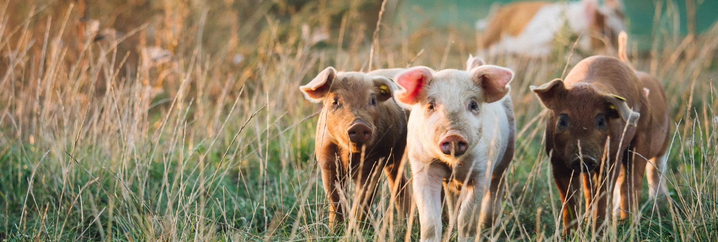

Next steps

Advancing sustainability in the British pork sector
The British pork sector has already made significant progress in improving environmental performance, driven by long-term gains in efficiency, productivity and innovation. The next phase must now focus on the factors that could limit further progress, while scaling the approaches that are already proving effective in practice.
These challenges include gaps in data availability, inconsistencies in measurement approaches, variable adoption of on-farm technologies, regulatory complexity and the challenge of integrating sustainability measures within commercially viable systems. Addressing these barriers will be essential if the sector is to continue improving environmental performance while maintaining resilience and competitiveness.
A whole-farm perspective is essential. Many pig enterprises operate within mixed farming systems, where arable and other agricultural activities play a critical role in managing nutrients, carbon, land and water. Addressing these issues in isolation risks missing system-wide efficiencies and unintended trade-offs.
This section sets out the priority areas for further investigation, collaboration and investment. Together, they provide a clear framework to guide stakeholder engagement, future research and strategic decision making across the sector.
- Net carbon – Improve the sector’s carbon balance, including continued gains in feed efficiency, stronger carbon accounting and better understanding of sequestration potential.
  - Establish a robust baseline for greenhouse gas emissions, soil carbon and above-ground carbon on a representative sample of pig farms by 2026
  - Analyse baseline data to identify key drivers of improved carbon balance by mid-2027
  - Quantify carbon sequestration potential on pig farms through targeted case studies
  - Identify and promote practical management approaches that enhance carbon removals
  - Evaluate cost-effective mitigation measures that also improve productivity
  - Monitor developments in alternative protein sources (e.g. peas, beans, insects), including research needs, regulatory considerations and alignment with FSA requirements
  - Address inconsistencies between unit-level and whole-farm carbon accounting approaches
Identify long-term data custodians and establish governance for emissions and carbon data
Better evidence the carbon contribution of UK-grown cereals within pig diets
- Air quality – Reduce ammonia emissions through better management, practical guidance and wider uptake of mitigation measures
  - Explore new mitigation strategies, including improved manure management and innovative housing solutions
  - Identify emerging on-farm technologies and publish clear, practical guidance
  - Support the adoption of best practice through guidance and, where appropriate, incentives
- Water stewardship – Improve water efficiency and strengthen protection of water quality
  - Collect and analyse existing on-farm water-use data to establish a sector baseline
  - Integrate water use into life cycle assessments (LCAs) by 2029
  - Roll out flow-risk mapping across outdoor pig units where appropriate
  - Support research into efficient water management, reuse and conservation strategies
Collaborate with government on Water Framework Directive obligations, including improved slurry storage and spreading technologies
- Slurry, manure and nutrient management – Improve nutrient efficiency and increase the value recovered from slurry and manure
  - Identify innovative uses for pig manures including nutrient recovery and circular economy opportunities
  - Work with government to secure support for improved manure storage infrastructure
  - Optimise slurry treatment and expand nutrient recovery including phosphorus recovery
  - Investigate the potential for slurry to be converted into biofertilisers or energy through approaches such as pyrolysis or microbial fuel cells
  - Explore emerging technologies for converting slurry into clean water and energy, including reverse osmosis and electrochemical treatment
Leverage innovation funding (UKRI, Defra, Agri-Tech Centres) to support scale-up and deployment
- Biodiversity and natural resource stewardship – Strengthen the sector’s contribution to nature, soil health and wider ecosystem resilience
  - Define and adopt sector-appropriate biodiversity metrics
  - Establish a baseline for soil biodiversity, with systems for ongoing monitoring
  - Identify and share best-practice case studies
  - Address the complexity of biodiversity net gain (BNG) in mixed farming systems
  - Support uptake of environmental stewardship agreements
Improve soil structure and long-term fertility through rotational practices, optimising the benefits of outdoor pig systems while mitigating potential soil impacts
- Waste and recycling – Reduce waste and improve resource efficiency across pig businesses
  - Develop and implement comprehensive waste reduction and recycling plans
  - Increase recycling of operational inputs including feed and pre-mix packaging
Assess opportunities for anaerobic digestion and circular economy approaches
- On-farm energy – Improve energy efficiency and expand the role of renewable energy on farm
  - Maximise renewable energy integration, particularly solar on new pig housing
  - Increase on-farm energy generation to improve self sufficiency
  - Improve efficiency in heating, ventilation and housing infrastructure
  - Explore heat recovery and slurry-cooling technologies, including retrofit options
  - Promote simplified planning processes and access to government grants to support investment

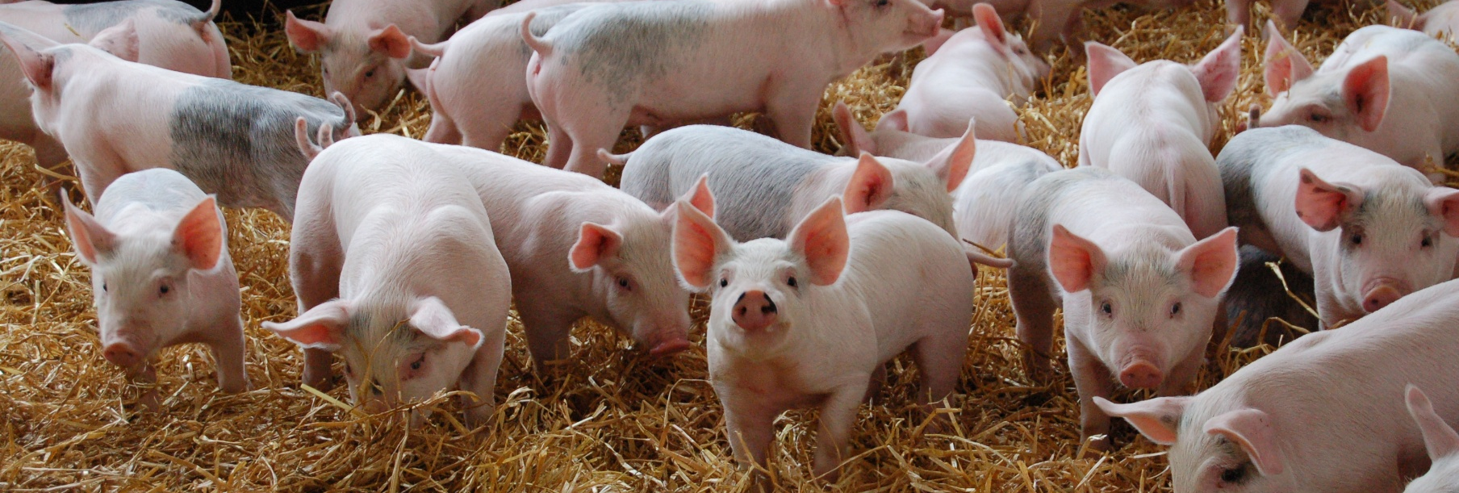

This Roadmap will enable the Pork sector to step up in its role in addressing environmental challenges and will be executed taking the following steps.

Action plan 2026–2030
The action plan translates the roadmap’s seven priorities into a phased programme of delivery. It is intended to be dynamic and responsive, providing direction rather than a fixed checklist. Delivery will depend on collaboration across producers, processors, levy bodies, researchers, government and other supply chain partners. It provides direction, but it is not fixed, actions should evolve as new evidence, technologies, policy developments and opportunities emerge.

2026 | Establish baselines and frameworks
Priority area | Key focus | Key output | Success measure
Net carbon | Establish sector baselines | GHG, soil and biomass carbon baseline | Baseline published
Air quality | Review mitigation options | Updated ammonia mitigation guidance | Guidance agreed and available for use
Water stewardship | Establish baseline | Sector water-use baseline | Farms contributing data
Slurry and nutrients | Identify infrastructure gaps | Evidence base for storage and spreading needs | Priority needs defined
Biodiversity | Define metrics | Sector biodiversity framework | Metrics agreed
Waste and recycling | Align practice | Sector recycling and compliance guidance | Audit compliance
On-farm energy | Benchmark performance | Energy audits and kWh/pig baseline | Baseline established

2027 | Enable adoption
Priority area | Key focus | Key output | Success measure
Net carbon | Identify drivers | Carbon balance driver analysis | Priority levers identified
Air quality | Support adoption | Ammonia mitigation pathways | Evidence of uptake
Water stewardship | Manage risk | Flow-risk mapping (outdoor units) | Coverage achieved
Slurry and nutrients | Launch pilots | Nutrient recovery and treatment pilots | Pilot data available
Biodiversity | Establish baseline | Soil biodiversity baseline | Data set published
Waste and recycling | Improve segregation | Farm-level recycling plans | Reduced landfill waste
On-farm energy | Improve efficiency | Lighting, heating, ventilation upgrades | Reduced energy use

2028 | Scale best practice
Priority area | Key focus | Key output | Success measure
Net carbon | Demonstrate removals | Sequestration case studies | Credible ranges evidenced
Air quality | Scale delivery | Wider uptake of mitigation | Improved compliance trends
Water stewardship | Improve efficiency | Water-use best-practice guidance | Adoption evidenced
Slurry and nutrients | Optimise use | Updated nutrient efficiency guidance | Increased nutrient recovery
Biodiversity | Share practice | Case study library | Uptake of measures
Waste and recycling | Assess circular options | AD and circular economy reviews | Priority opportunities identified
On-farm energy | Expand renewables | Solar and on-farm generation scaled | Increased self sufficiency

2029 | Measure impact (LCA year)
Priority area | Key focus | Key output | Success measure
Net carbon | Lock data | 2028 data set for LCA | Data ready complete and ready for assessment
Air quality | Evidence outcomes | Ammonia impacts assessed | Reflected in LCA
Water stewardship | Integrate metrics | Water included in LCA | Metrics reported
Slurry and nutrients | Assess impact | Nutrient impacts quantified | Reduced losses evidenced
Biodiversity | Build evidence | Biodiversity outcomes review | Credible evidence
Waste and recycling | Review performance | Sector waste metrics | High recycling rates
On-farm energy | Quantify gains | Energy impacts in LCA | Verified reductions

2030 | Reset
Priority area | Key focus | Key output | Success measure
Net carbon | Reset ambition | Updated roadmap targets | Clear future trajectory agreed
Air quality | Continuous improvement | Refined mitigation priorities | Continued reductions
Water stewardship | Stewardship alignment | Aligned actions | Reduced water risks
Slurry and nutrients | Scale solutions | Viable technologies adopted | Wider uptake of practical solutions
Biodiversity | Integrate schemes | BNG and stewardship alignment | Increased participation
Waste and recycling | Embed practice | Business-as-usual recycling | Sustained compliance
On-farm energy | Long-term resilience | Integrated energy systems | Cost and carbon savings

References

Defra, 2023. Agriculture in the United Kingdom 2023. Chapter 2: Structure of the agriculture industry in England and in the UK at June 2023.
FAO. 2009. Feeding the world in 2050.
DESNZ, 2024. Provisional UK greenhouse gas emission statistics 2024. Accessed May 2025.
Defra, 2023. Agriculture in the United Kingdom 2023. Chapter 11: Agri-environment.
IGD, 2024. A Net Zero Transition Plan for UK Food Systems.
UN Framework Convention on Climate Change. 2016. The Paris Agreement.
FAO. 2023. Pathways towards lower emissions – A global assessment of the greenhouse gas emission and mitigations options from livestock agrifood systems. Rome.
Defra, 2024. Livestock populations in the UK at 1 June 2024.
Defra, 2010. Pigs and poultry farm practices survey 2009. Accessed Dec 2024.
AHDB. 2024. Pork market summary 2024.
United Nations. THE 17 GOALS | Sustainable Development.
Defra. 2024. Agri-climate report 2024. Accessed Dec 2025.
Ottosen et al., 2021. Changes in the environment impacts of pig production systems in GB over the last 18 years. Agricultural systems 189.
McAuliffe et al., 2022. Protein quality as a complementary functional unit in life cycle assessment (LCA). The International Journal of Life Cycle Analysis. 28, p146–155.
FAO, 2021. Integration of environment and nutrition life cycle assessment of food items: Opportunities and challenges. Rome.
Poore and Nemecek, 2018. Reducing food’s environmental impacts through producers and consumers. Science, 360, 987-992.
Defra. 2024. Farm practices survey – Greenhouse gas mitigation.
Defra. 2021. Delivering Clean Growth Through Sustainable Intensification. Accessed May 2025.
SRUC. 2025. The evaluation of market-ready agricultural technology options.
AIC. 2023. Feeding livestock with soya – Why is it important and how sustainable is it? Accessed April 2025.
Fairr. 2019. Amazon Soy Moratorium.
National Pig Association. 2020. NPA Highlights Commitment to Sustainable Soya after Government Rainforest Announcement.
Houdijik et al., 2012. The environmental consequences of using home-grown legumes as a protein source in pig diets (Green Pig).
Legume Innovation Network. 2021. The EU Market for peas.
Defra. 2025. Life cycle assessment of UK insect protein production processes for pig and poultry feed.
Pomar and Remus, 2019. Precision pig feeding: A breakthrough toward sustainability. Animal Frontiers 9 (2), 52–29.
Carsewell et al., 2024. Inventory of Ammonia Emissions from UK Agriculture 2023. Rothamsted Research.
Defra. 2019. Clean Air Strategy 2019: executive summary.
Defra. 2023. British survey of fertiliser practice 2023.
The Waste Management (England and Wales) Regulations 2006 (S.I. 2006/937).
Van Zanten et al., 2023. Circularity in Europe strengthens the sustainability of the global food system. Nature Food 4, 320–330.
AHDB, 2021. What's the return on investment of air scrubbers? Accessed June 2025.
Allary, T. 2025. Discussion summary: On-farm AD summit 2025. AD Summit Article June 2025

