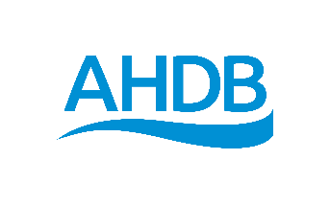
Review framework
This template can be used to capture outcomes both formal and informal reviews. It will help you initiate a balanced discussion of what has gone well and not, and help mutually agree actions which can be monitored.

Focus of the review

What went well and why? | What could have gone better and why?
What do we need to change or do differently? | When will this happen?
Other feedback or ideas
Next review date

